Single Change Plan for School Improvement

Sandringham Federation of Church of England Primary Academies

Sandringham and West Newton CE Primary Academy September 2018-August 2019

‘Live together, Learn together, Play together’
Our Academy Vision
We create a warm, inclusive and stimulating environment for all children, aiming to ensure that children enjoy school and develop the love of learning. Through partnership with parents and the community we will help children reach their full potential.
We do this through:
- Developing a sympathetic understanding of the Christian faith and a respect for the other major world religions
- Aiming for the highest possible standards of work and behaviour
- Promoting positive relationships with parents, the Church and the wider community to enable us to provide the best possible learning experiences for our children
- Sustaining a broad and balanced curriculum which meets the needs of our children and promotes their spiritual, moral, cultural, mental and physical development
- Providing a welcoming, stimulating, safe and comfortable environment in which all children have equal opportunity for success and are fully supported so they can reach their full potential
- Encouraging our children to develop personal independence, so fostering an attitude of love and respect towards others and towards God’s world

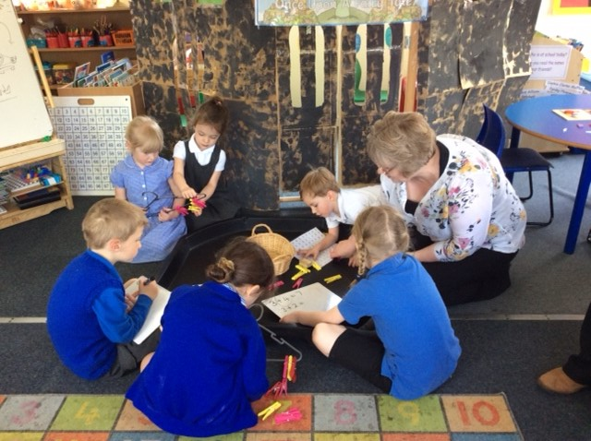

Data Context for 2018-19 Single Change Plan

Key Themes from 2018 KS2 SATS Question Level Analysis:

Maths:
- Children are good at arithmetic scoring in line with national or higher: however with introduction of Multiplication test from 2019/20 a refocus on times tables and four number operations will provide a solid foundation to maths across the academies.
- Only specific weakness statistics -13% on QLA

Reading:
- Main area of weakness making comparisons to the text -20% on QLA.

SPAG:
- Grammatical terms/word classes need to improve -28% on QLA
- Combining words/phrases/classes poor -23% on QLA
- Spelling needs to improve -13% on QLA

Key Themes from Key Data 2018:
- Maintaining EYFS as a strength with strong results 100% 2018. Promote EYFS PHYSICAL though and aim high for more to promote GLD 3 %.
- Maintaining Phonics (y1) as a strength with better than national results (trend over time).
- Maintain strong KS1 results – ensure higher standard (GDS) in R/W/M combined and Reading alone improve to in line with National.
- Improving progress scores from Ks1 to Ks2 in writing to be in line with Reading and Maths and at least at expected progress measure 0+
- Improve attainment and progress of middle and higher prior attainment groups across core subjects.
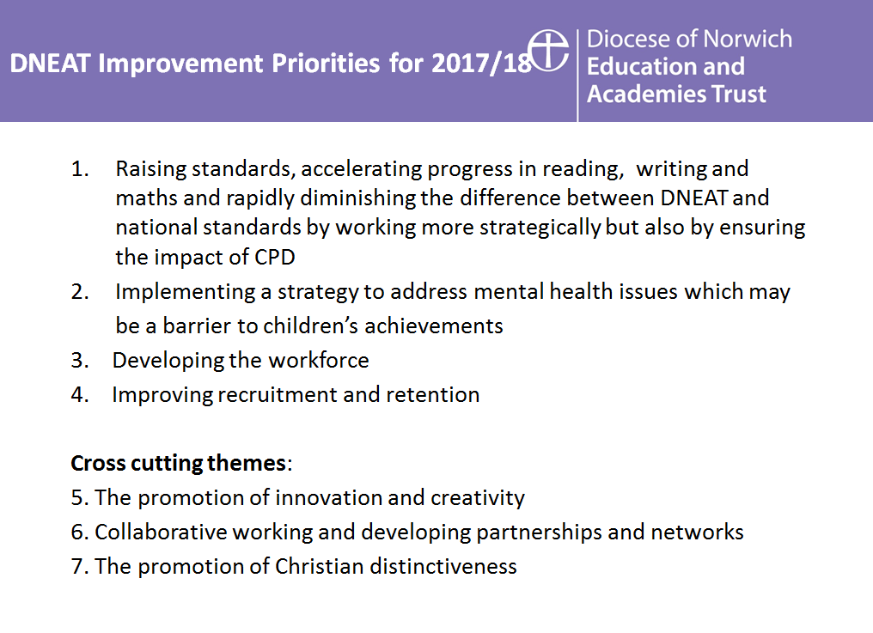
School Key Priorities As part of the new partnership arrangement with Flitcham Primary Academy, both schools will work together. The strength of working in partnership to develop staff and enrich the pupil experience and learning opportunities will be a priority for this academic year and will be a thread through all school development activities.

Priority 1 related to : Quality of teaching, learning and assessment : To develop writing to ensure that all pupils achieve their full potential, increasing numbers of pupils attaining expected standard at KS2 and increasing numbers of pupils reaching greater depth standard at KS1 and KS2, with a particular focus on middle ability and higher ability prior attaining groups, ensuring progress measure by the end of KS2 are at least in line with national. Through the development of cooperative learning throughout the curriculum increased engagement, will ensure a greater percentage of pupils reach their full potential.
Priority 2 related to: Outcomes for Pupils: To develop collaborative learning for pupils in all curriculum areas, to promote resilience and independence, encouraging pupils to be working harder than the teacher. As a result of improved teaching methods, pace will be improved, thereby ensuring pupils make as much progress as possible, achieve their full potential and lessons are filled with challenge and engagement.
Priority 3 related to : Personal development, behaviour and welfare: To ensure the Christian values of the school are developed through a shared vision, related to a theological text and are promoted for the enhancement of behaviour and welfare in school, using Roots and Fruits provision and in conjunction with Pivotal training for behaviour. In addition the school will attain the RE quality mark this year.
Priority 4 related to: Leadership and management: To promote subject leadership across the federation, including embedding new staff and providing appropriate support and CPD.
Priority 5: related to EYFS provision: To further enhance the outdoor provision and to ensure new teaching staff are supported. To monitor the development of physical attributes of GLD as this was a weakness this year and to achieve at least 14% GLD 3 this year.

Quality of Teaching, Learning and Assessment
 | Objective | How will we achieve this? | Success criteria/Impact | Monitoring/  Evaluation | Cost | Person(s) Leading | Milestones | Evidence and Evaluation
1.1 | To ensure the consistency of practice so all is Good or Better | - Weekly teaching and learning meetings which build on identified areas of need  - Frequent learning walks and drop ins to gather evidence on all areas of Quality of teaching  - Ensure staff have opportunities to attend in house or external CPD. | - 100% of teaching and learning will be Good or Better  - CPD for professional development will be self-perpetuating with staff seeking on-going support from colleagues and some external courses.  - IMPACT – Consistently improved quality of teaching = accelerated progress | SLT/EHT | Some CPD courses – release costs from class. | SLT | BY Autumn 2018 – 100% Good or better  By Spring 2019 increase % of OS teaching to 25%
1.2 | All books to show clear progress from starting point and work matched to pupils needs  To also include a focus on presentation throughout curriculum. | - PPA opportunities to work and plan together given to staff  - Effective use of tracking system to identify further differentiation or support needed  - Pupil feedback is useful and age-appropriate  - Consistency across curriculum | - Consistency of expectations across year groups  - Teachers regularly accessing PIXL and Pupil Progress Tracker to monitor the impact of teaching and learning on all groups within their class  - Pupils are able to understand and use feedback and share that this is useful to them through pupil voice  - IMPACT – Improved Pupil Progress | Subject Leaders with responsibility for Appraisal plus EHT | N/A | SLT | Autumn 2018 – 100% Core good or better  Summer 2019 – 100% Foundation good or better
1.3 | To review timetabling to build in time to do 1:1 or small group consolidation/misconception work or feedback with pupils | - Senco and teachers identify pupils needing support and plan intervention using PIXl and other material.  - Short independent activities planned in  - Use of support staff effectively when you have them  - To provide staff with more time to support children with metacognition | - Pupils have a clear understanding of their areas of strength and development and are confident in their next steps  - Pupils are able to work independently whilst teacher is completing focus/targeted work with identified students  - IMPACT – Improved Pupil Progress | SLT/SENCO | N/A | EHT/Senco | Autumn 2018 – increased progress in vulnerable groups compared to Autumn starting points.
1.4 | To ensure full curriculum coverage within the academic year | - Subject leaders to monitor coverage | - IMPACT – Greater levels of pupil engagement and improved attainment | SLT | N/A |  | On-going throughout year – termly review by subject leaders  CPD January 2019 – curriculum overview day
1.5 | To use electronic tracking system (Pupil Asset) to ensure all teachers know the progress and attainment of all groups within their class – work with PIXL to support intervention. | - Pupil Asset tracker installed and being used effectively  - Staff understand how to look at progress of groups within their class  - To use for summative assessment on termly basis  - Link assessment to pertinent intervention as needed. (PIXL) | - Pupil Asset updated half termly by all staff and group/subject progress and attainment feeds into planning  - IMPACT – Work even more closely matched to pupil needs and pupils and teaches more aware of pupil progress from starting points. | SLT | On-going PA and PIXL subscription | Class Teachers | End Autumn 2018 all teachers familiar with PA/PIXL data sheets.  Parents receive helpful pupil info at parents’ eve October 2018.
1.6 | To ensure accuracy of assessment and evaluation | - All teachers will attend cluster and DNEAT moderations sessions throughout the year especially in writing and Maths. | - 100% of teacher will be confident in judging writing against ITAFS (Y2 and 6) and PIXl trackers from year 3-5 | EHT /Subject leaders | NA | Subject leaders E and M plus EHT | Termly from October 2018
1.7 | To ensure that key themes from the assessments are used to inform teaching and learning | - Analysis done and shared with staff  - Planning ensures key areas of weakness i.e. teaching of spelling throughout school and basic arithmetic/times tables is improved.  - Areas of weakness in reading comprehension addressed through PIXL. | - Teachers are more confident in areas to work on.  - Intervention in small groups/whole class is used in conjunctions with the new PIXL resources to target weak areas | EHT/HOS | PIXL cost £1800 | EHT plus Maths/  English leads | In place by Half term October 2018 – monitored throughout year.

Outcomes for Pupils
 | Objective | How will we achieve this? | Success criteria/Impact | Monitoring/  Evaluation | Cost | Person(s) Leading | Milestones | Evidence and Evaluation
2.1 | To ensure the gaps for identified vulnerable groups are narrowing/closing | - Pupil Asset will clearly identify for staff how all groups of pupils in their class and sets are performing – staff to check regularly  - Regular 1:1 pupil progress meetings take place to hold staff to account for pupil performance and to focus on vulnerable group gap closing  - Clear tracking of impact of intervention groups for SEN and Pupil Premium | - Teachers will have checked group attainment and progress regularly – half termly and use this to inform planning  - 1:1 pupil progress meetings will take place for all teaching staff every half term to discuss focus pupils in key under-achieving groups including Sen and More able.  - The impact of SEN and Pupil Premium spending will be clearly measurable  - IMPACT – Closing the attainment and progress gaps for all | EHT/SLT/  SENCO | N/A | EHT | Termly impact report for SEN and Pupil Premium presented at SLT  Dec 18  March 19  July 19
2.2 | To ensure the attainment and progress of pupils at end of KS1 and KS2 SATs exceeds National Average (including combined R,W and M)  And to ensure that pupils make good or better progress in core subjects. | - On-going discussions with staff as to the current predicted status and evidence – using PIXL trackers/PA  - Use of raising standards groups for identified pupils  - 1:1 tutoring for identified pupils  - SATs Club for KS2 starting in January and running to May | - Any under-achieving group or pupils will have a programme in place to accelerate progress  - Termly review of evidence and statistics will be closely reviewed and additional support put in as needed  - Whilst all pupils will be invited to SATs club – additional personalised letters/phone calls to parent(s) of target pupils to ensure they attend  - IMPACT – Attainment and Progress for KS1 and 2 in line with National 2019 and progress measures improve from 2018 results. | SLT | N/A | Subject leaders and EHT | Termly impact report presented at SLT and support revised as required  Dec 18  March 19  July 19
2.4 | To develop the skills and knowledge of pupils across a range of foundation subjects so that the attainment reflects core subjects especially in writing. | - Planning for cross-curricular experiences where possible to ensure English and Maths skills are used and applied across the curriculum  - To ensure foundation evidence is included in moderation | - Cross-curricular opportunities will be a main focus of book monitoring  - Writing moderation will include books where there is evidence of cross-curricular writing above and beyond the English books  - Maths moderation and evidence will be gathered from across the curriculum, not just maths books  - IMPACT –Evidence to support Writing outcomes across KS1 and KS2 is stronger. | SLT | N/A |  | Termly review and moderation

Personal Development, Behaviour and Welfare
 | Objective | How will we achieve this? | Success criteria/Impact | Monitoring/  Evaluation | Cost | Person(s) Leading | Milestones | Evidence and Evaluation
3.1 | To promote the Houses within school | - More House events throughout year, including assemblies in houses and key events. | - Pupils will have the opportunity to work in Houses – i.e. enjoy the benefit of cross age groups – increasing identity of the Houses across school. | EHT/SLT | Per event | SLT and House teachers | Termly events from Autumn 2018
3.2 | To ensure that pupils are aware of personal safety | - To have termly internet safety lessons as part of ICT lessons  - To have invited speakers in eg: PCSO to talk on a variety of subjects  - To ensure all pupils are aware of road and cycle safety | - Children will be aware of dangers of the internet, especially use at home  To ensure that pupils have good road awareness | EHT | 0 | EHT | Termly – monitored through planning  Invited speakers when available.
3.3 | To promote the School’s Christian values through weekly collective worship, with a focus on one value per half term | - Values assemblies are in place and class teachers link to the Christian values in PSHE and Circle time in class.  - Use Roots and fruits material so all staff have ready resource, linked to Christian values and shared with incoming clergy. | - Values to remain in entrance hall to keep up high profile and be in all classes/shared areas  - events  - IMPACT – Pupils understand the importance of Christian values and can relate them to their own lives. | SLT |  |  | Termly review of impact through Ethos committee.

The Effectiveness of Leadership and Management
 | Objective | How will we achieve this? | Success criteria/Impact | Monitoring/  Evaluation | Cost | Person(s) Leading | Milestones | Evidence and Evaluation
4.1 | To develop the senior leadership structure to provide more secure, and sustainable leadership in developing the Head of School role and using support of partnership and DNEAT AGEP. | - To work with AGEP on creating the most effective way to operate as an SLT using the individual skills of each member – especially embedding new HOS in January.  - SLT meetings to run in a more strategic rather than problem solving manner  - All staff are clear on the SLT structure and who is responsible for what and what to do if that person is not available | - AGEP advice shared with SLT  - SLT used the feedback from the school improvement advisor to adjust their approaches and systems to ensure maximum impact  - All staff know the systems that are in place and who to go to in the event of needing advice or support so time is efficiently and effectively used | SLT | Included in better to best | SIA and HT | SIA work completed by end of Autumn term 18  Any new practices agreed and implemented by end Nov 18
4.2 | To continue to develop subject leaders and ensure that all subjects are well led and monitored, especially with a focus across the partnership. | - Leaders meetings held regularly to ensure consistency of approach and expectation – all singing from the same hymn sheet  - All subject leaders to be actively involved in monitoring their subject, through learning walks/work scrutiny etc.  - 1:1 / groups sessions for  - leaders to discuss any issues they may have and provide coaching /mentoring to develop leadership styles | - Core leaders attend core moderation through DNEAT and PIXL conferences.  - Middle and senior leaders are confident in executing their role and feel supported  - School leadership at all levels is sustainable  - IMPACT – More effective leadership at all levels and a sustainable profile for the school | EHT | Release time where needed for monitoring. | SLT | Training booked for all core leaders E/M//S/Humanities/RE  ,November.  On-going with termly review at end of each term to review success and impact  Dec 18  Mar 19  July 19  Termly report to FGB by one subject leader.

Safeguarding
 | Objective | How will we achieve this? | Success criteria/Impact | Monitoring/  Evaluation | Cost | Person(s) Leading | Milestones | Evidence and Evaluation
5.1 | To regularly develop and refresh staff knowledge and understanding of CP and Safeguarding | - Termly workshops available for staff to sign up to in order to refresh knowledge  - Frequently revisited at all staff and TA/LSA/Office/Site meetings to keep high profile  - Where any procedures are not followed to offer support and if needed to issue a management instruction letter | - Refresher sessions and workshops are in place and staff have been given the opportunity to attend or directed to attend  - All staff follow all CP/Safeguarding procedures correctly using the correct forms/paperwork  - IMPACT – Outstanding CP/Safeguarding practices in place for our children and staff | HT | N/A | SLT | Termly review with triangulation documents and discussions on what is needed provision wise
5.2 | To apply for RE QM | - All staff aware in staff meeting session  - Use of new DNEAT RE objectives | - IMPACT – Increased rigour with which RE assessed and impact on curriculum. | HT | Ethos Govs | SLT | By end of Autumn 18 term
5.3 | To ensure monthly CP/Safeguarding update meetings happen to ensure all have current knowledge of all active cases and concerns | - Monthly meeting dates are in place and are sacrosanct  - All staff with responsibility for cases have current knowledge in case they need to deal with or attend meetings that are not their own caseload | - Monthly update meetings take place  - All staff are confident to attend and work on cases which were not initially theirs as knowledge is there  - IMPACT – More effective communication with each other and other agencies as all have key information | HT | N/A | SLT | Monthly – on-going

SMSC
 | Objective | How will we achieve this? | Success criteria/Impact | Monitoring/  Evaluation | Cost | Person(s) Leading | Milestones | Evidence and Evaluation
6.1 | To celebrate cultural and religious diversity | - Highlighting and sharing key festivals and celebration  - Ensure that development points from SIAMS inspection are addressed – such as visits/visitors. | - Pupils will have a greater understanding and appreciation of the cultural diversity within school  - Pupils and families will all feel that their cultures are being equally understood and respected  - IMPACT – pupils will have a greater knowledge of cultural diversity. | SLT | N/A | SMSC lead | As per planned annual events  Plus linked to Learning Together days.
6.2 | To develop pupil understanding of The Rule of Law and Democracy | - Pupils to learn about workings of the houses of parliament  - All pupils to understand democracy and the rule of laws through PSHE lessons | - Pupils are able to explain how democracy and the rule of law works in the UK and abroad  - IMPACT – A greater understanding of different countries systems | SLT | N/A | SMSC Lead | On-going throughout year
6.3 | To refresh GTBG | - Ensure all staff and pupils have a refresher of GTBG system | - EHT/SLT to ensure promoted in assembly and to ensure consistency. | EHT/SLT | NA | EHT | By September 2018  Report to FGB through HT report
6.4 | To implement new Pivotal behaviour programme in Spring term | January 2019 INSET with cluster schools using When the Adults change the behaviour changes.  Reinforced in regular update sessions/staff meetings. | - EHT/SLT to ensure promoted in assembly and to ensure consistency | EHT/SLT | NA | EHT | By first half Spring term 2019 – Ethos and Gov monitoring | Behaviour for learning improves

Developing Community and Parent Links
 | Objective | How will we achieve this? | Success criteria/Impact | Monitoring/  Evaluation | Cost | Person(s) Leading | Milestones | Evidence and Evaluation
7.1 | Where significant changes are being discussed in school, to ensure that parents feedback is sought to feed into this process before any decisions are made | - Questionnaires or feedback forms are drawn up for identified consultation areas and sent home to parents to gain views  - Views of parents as well as other stakeholders are taken into account before any decisions are made | - Parental engagement is increased  - Parents feel their views are being listened to  - IMPACT – Improved positive parental feedback about the work of the school | SLT | tbc | EHT | Autumn – key areas identified and questionnaires drawn up eg: how can we help you help your children learn/read? etc
7.2 | To ensure a range of parent information sessions are run throughout the year to support parents in helping their children | - Parent information sessions are publicised to parents  - Learning cafes are organised for different subjects  - Survey for how we can help you help your child? | - Parents feel more confident in how to help their children at home  - Improved standards as a result of additional parental support  - IMPACT – Raised standards and improved parental confidence | SLT | In-house release | JQ | Termly – workshops identified and shared with parents Phonics and Cursive HW by end Autumn 2018  Maths in Spring term 2018
7.4 | To use Parent Forum to seek parental views on other information or support sessions they would like the school to facilitate throughout the year | - Parent suggestions are taken on board for what to include in sessions | - Parents feel their voice is being heard and acted upon  - -IMPACT – Improved relationships with parents | EHT | N/A | SLT/GOvs | Termly | .
7.5 | To re-vamp the newsletter to provide more information for parents on what has been happening, why and the impact it is having | - Newsletter re-vamped and extended to 4 paged to include more information and rational  - Feedback from parents on newsletter taken on board for any future changes | - Parents find newsletter more informative and respond positively to the contents  - Parents have a greater understanding of why actions have been taken  - IMPACT – Improved parental perception of school | HT | Paper cost for additional copying | SLT | Half termly | .
7.6 | To promote regular reading at home | - Reading cafes in school and workshops to promote reading skills and interest. | - Parents will be more confident in how we teach reading and pupils will have more opportunity to read at home. | SLT | NA | EHT | Termly in classes

School Site and Premises
 | Objective | How will we achieve this? | Success criteria/Impact | Monitoring/  Evaluation | Cost | Person(s) Leading | Milestones | Evidence and Evaluation
8.1 | To develop KS1 undercover area | - Awaiting final approval LCVAP funding Diocese  - Quotes obtained and design agreed,  - Order placed and install arranged  - Install complete and official opening arranged by January 2018 | Much improved learning space for KS1 class | EHT/HOS | £80k provided by DFC/LCVAP | HOS | All in use by Spring 2019
8.2 | To renew ICT contract | - Discussions with RM through DNEAT | Much improved IT provision across school in both offices and classroom | EHT | TBA | EHT | For New budget year April 2019
8.3 | To upgrade ICT equipment | - To purchase new chromebooks  For sharing in all years. | Pupils will have more opportunity to use IT related resources on tablets in classrooms, increasing cross curricular support. | EHt/SLT | £5K | EHT | In use Dec 2018

Staff Well-Being
 | Objective | How will we achieve this? | Success criteria/Impact | Monitoring/  Evaluation | Cost | Person(s) Leading | Milestones | Evidence and Evaluation
9.1 | To ensure staff feel valued - | Regular thanks in weekly newsletter/staff meetings | - Staff feel valued especially when going above and beyond | EHT | NA | EHt | Weekly
9.2 | To adopt a regular drop in approach to monitoring through learning walks in all subjects to evaluate the Quality of Teaching and Learning | - To start all staff meetings with positive news/good practice sharing.  - To ensure that drop-ins are limited to a maximum of 10-15 minutes unless there is a reason agreed to stay longer | - Staff feel they have some control over how often they are being visited and also have the option to show off what they are doing  - Appraisal staff are able to gain the information they need to make judgements without teaching staff feeling over-whelmed  - IMPACT – Greater consistency of practice observed and staff well-being being taken into consideration | SLT | N/A | Appraisers | On-going throughout year
9.3 | To have half termly staff social events | Arrange opportunities for staff to relax together and get to know partners at Sandringham too. | - Staff feel valued and have time to improve partnerships both in school and socially. | EHT | NA | All | Termly events

