**History**

We will be learning all about the Great Fire of London, and famous people of that time, such as, Samuel Pepys.

**Computing**

We will be learning what an algorithm is and having a go at writing our own.

**Science**

In science, we will be learning all about animals. We will be looking closely at different animals and classifying them using the terms reptiles, birds, amphibians, fish and mammals.

**Maths**

In maths, we will be covering work on numbers and place value, and on the four number operations, addition, subtraction, multiplication and division.

**PE**

We will be exploring different ways of travelling and balancing.

**Art and Design**

We will be using different materials to create a picture of the Great Fire of London. We will look at the artist Mondrian and use ‘fire’ colours to create a picture in his style.

**RE**

We will be learning about the Jewish celebration of Shabbat.

Year 1 and 2 Spring 1

Our topic is “The Great Fire of London”.

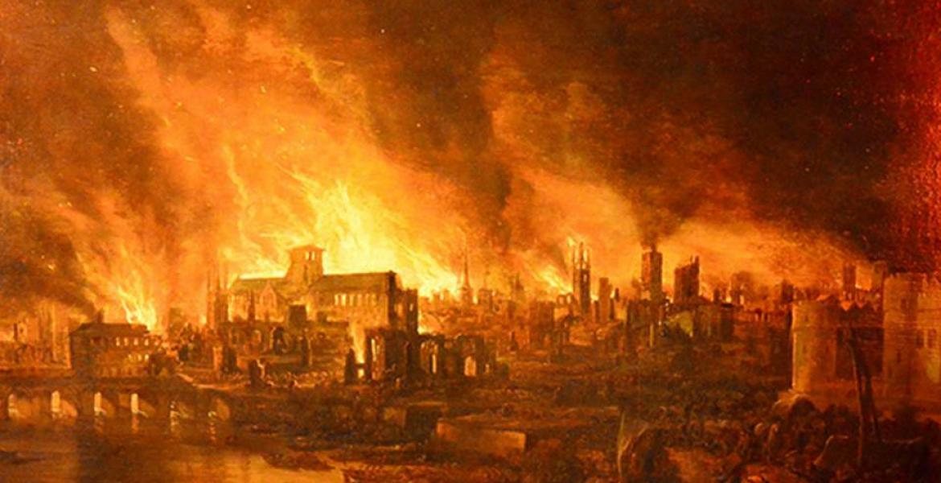

**English**

In English, we will be reading the story “Toby and the Great Fire”. We will be learning about the features of a diary and writing some fire related poetry.