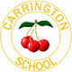CARRINGTON MATTERS

April 2015

**Welcome back!**

[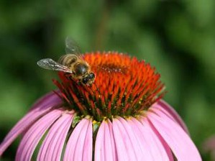](http://www.picsearch.com/imageDetail.cgi?id=LOvIJQ0cJslFDBeBumYivUvX9KcD5mE4NpwjM8U0bKk&start=1&q=summer&querySafe=unsafe)

Welcome back to our exciting Summer term. I am very much enjoying my first few days as our Acting Headteacher. We are all so lucky to go to Carrington Junior School.

We have lots of interesting events happening this term, be sure to check the events diary on the reverse of this newsletter. A list of new clubs will be circulated shortly and there are lots of interesting things to choose from including a cookery lunch club and an after school cookery club.

**Ipads have arrived !**

Huge thanks go to everyone on the PTA and all our parents and families who have contributed to raising funds for our first rack of 15 Ipads which have arrived, along with a charging trolley and are already in use in the classes. Staff have had a training session on our INSET day.The children are very excited and keen to use all the interesting apps.

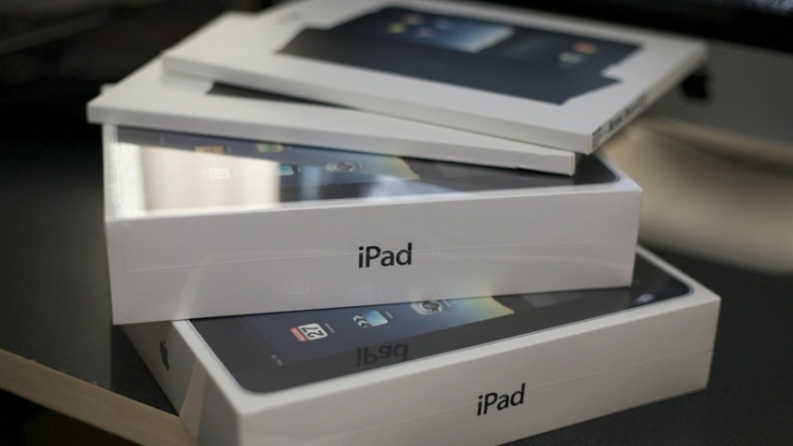

**House Cup Winners**

Congratulations to Emerald House for winning the House Trophy again for the Spring Term. House Captains Oliver, Sam and Safi tied their green Emerald house ribbon on in assembly to huge applause. Well done Emeralds and good luck to everyone for the Summer Term competition.

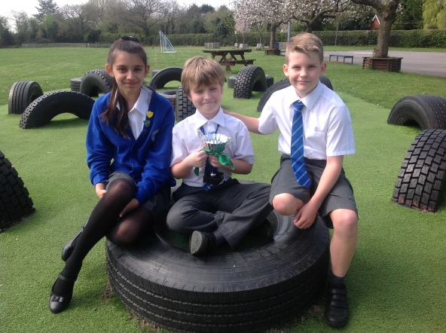

**Whole School Competition**

[](http://www.picsearch.com/imageDetail.cgi?id=pU_cXLIuABvfA44bCvtfwNE-F70Ko9gRwr8Q8OAmnGQ&start=1&q=cakes)

This term we will be having a Carrington Bake off as our main whole school competition. Start thinking of creative cakes you could bake to bring in, we will have professional judges, prizes will be awarded and then the cakes will all be sold to raise funds. In addition we will have a hoop netball and football house competition towards the end of this half term.



**14th April** – Children return for Summer Term

21st April – Twist in Time Theatre production 9.30am all classes.

22nd April PTA Film Night for Infants in junior school hall.

25th April Girls Brigada sponsored car wash in car park

28th April Year 6 trip to Hazard Alley

29th April PTA film night for Juniors in junior school hall 3.30pm £2

30th April Year 5 trip to Living Rainforest

4th May Bank holiday School closed.

5th May – Year 5 cycling week starts

7th May – New headteacher interviews

11th May – Year 6 SATS week

15th May – Year 6 end of SATS party

18th May – Year 6 Cycling week

19th May – New Mozart Orchestra performance to all children in hall 9.30 am

22nd May – Class photos – break up for half term

22nd June – Year 4 Woodrow trip info evening

25th June – New parents’ meeting 2pm

5thJuly - Summer Fayre

6-8th July – year 4 Woodrow residential trip

10th July – Sports day – combined lunch picnic with infant school – Junior sports in 1.30pm.

20th July – End of year PTA disco

22nd July – Break up 2.15pm



**Stars of the Week**

**Here are our super Stars from the week before the Easter holidays.**

**Hawthorn –** Ellis Rathbone

**Maple –** AlfieDudman-West

**Elm –** Grace Milner

**Cherry –** Chosen Tejada

**Chestnut –** Christopher Lee

**Rowan –** Nathan Walford

**Oak –** JobieZajacAcheamopong

**Beech –** Oliver Dolbear

**Willow –** DerrenYearwood,OliviaOleszczuk, Jack Earl, LibbiFoden

**Mrs Martin** – Owen Griffiths

**Looking Ahead**

In conjunction with the Infant School we have arranged two INSET days in the Summer term on 11th and 12th June