**Computing**

We will learn how to create and debug algorithms.

**PE**

We will be developing our ball skills and learning to play tennis. We will also be practising for sports day.

**Science**

In science, we will be learning all about plants. We will be planting beans and find out the best ways to help them grow. We will be identifying plants and trees that can be found in the school grounds.

**Year 1 and 2 Summer 1**

**Our topic is “Castles”.**

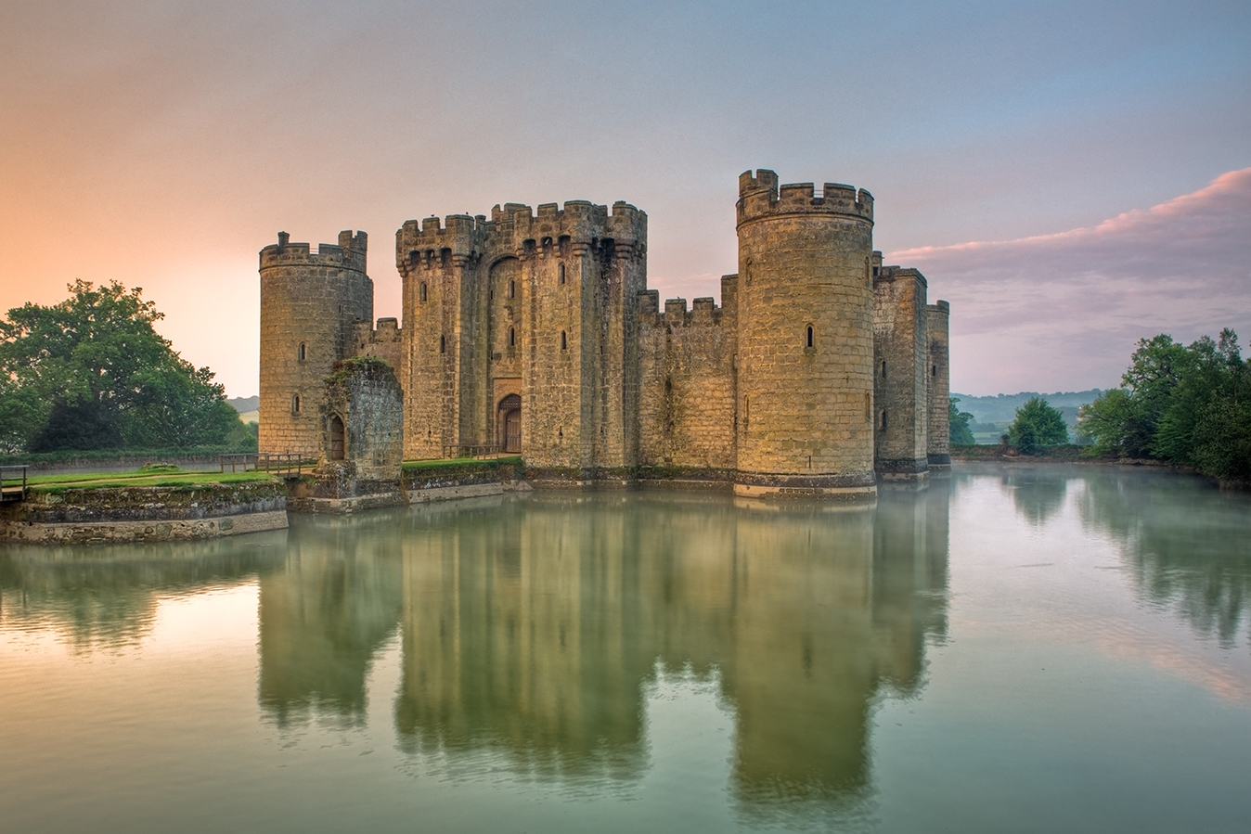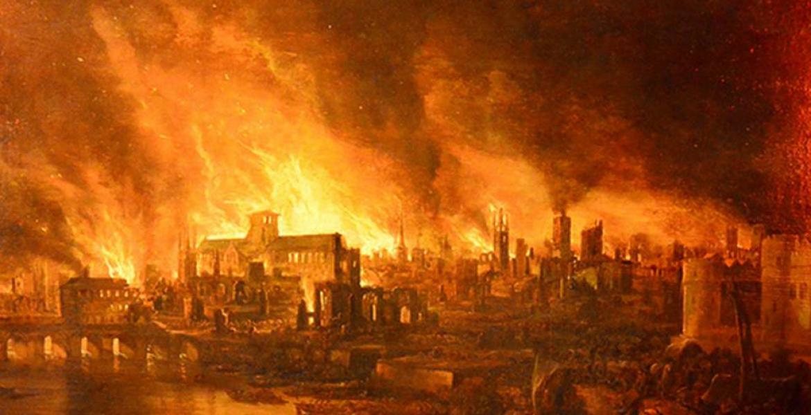

**History**

We will be learning all about the castles. We will find out the main features of castles and explore what it was like to live in a castle.

**Maths**

In maths, our focus will be on solving problems involving addition, subtraction, multiplication and division. We will also revisit fractions of shapes and numbers.

**Art and Design**

We will be making a winding mechanism to create a drawbridge. We will look at the picture ‘Castle and Sun’ by Paul Klee and create our own version.

**RE**

We will be looking at the concept of creation and exploring the question ‘Who made the world?’.

**English**

In English, we will be reading the story “Jack and the Beanstalk”. We will be thinking of words to describe the characters and writing our very own story about the giant!