Dear Parents,


Before we have even finished our Easter eggs, the Summer Term has quickly crept upon us! It promises to be an action packed term including sporting events, the KS2 production and the Sandringham Flower Show with lots of opportunities to get outside, so let’s hope the weather is good.
Our topic learning will focus on Vikings and will link to our English where the children will be studying ‘How to Train Your Dragon’ by Cressida Cowell. It is through this study that we will focus on Reading Comprehension skills which have been identified as an area for the children to practice. It would be really helpful to ask your children questions about what they are reading at home as well to the reinforce this.

We will also be becoming Grand Master Dragon Keepers, as we open a dragon egg shop in our classrooms and design different species of dragon before creating manuals on how best to look after these magnificent creatures.
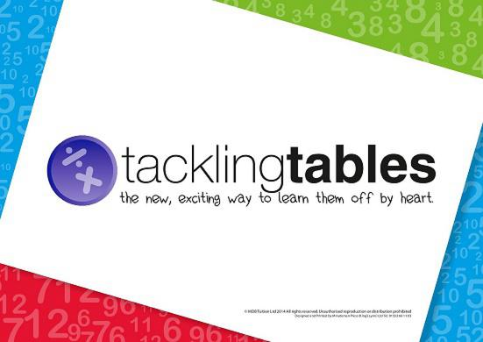
As ever, it is important for the children to continue to practice their times tables. I would really like to move some of the children on with their Tackling Tables this term. Remember, all the children have a log-in to the Tackling Tables App and are welcome to log-in and practice any time.
In Maths, we will be working with the children to consolidate their learning from this year through reasoning and problem-solving. This requires the children to apply their knowledge to range of different contexts. It can be tricky, but I have no doubt that the children are up for the challenge.
Forest Schools and PE continues to be on alternate Thursday afternoons and homework will be set on a Tuesday to hand in on the following Monday. The children will be tested on their spellings by Mrs Patnell each Friday.
Do not hesitate to come in and see me if you have any concerns or questions. Enjoy the Summer Term!
With kind regards,
Mrs King, Mrs Patnell and Mrs Massen

