September 2019
Dear Parents and Carers,
Welcome back! I hope that you enjoyed a wonderful summer and that your children are feeling refreshed (although you may not be!?) and ready to take on the challenges of the Autumn term.
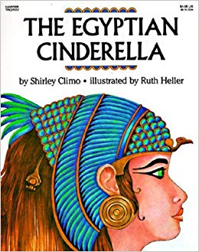
Our topic learning will focus on Ancient Egypt and will link to our English where the children will be studying ‘The Egyptian Cinderella’ by Shirley Climo. It is through this book study that they will practice reading comprehension skills and focus on our presentation, punctuation and handwriting. If some children can consistently demonstrate that they present their work beautifully using cursive handwriting then they may earn a pen license.
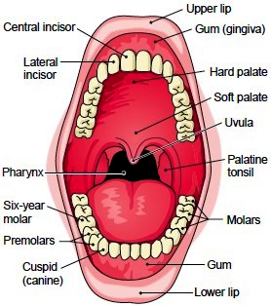
I would also like to emphasise the importance of reading at home and have given the children the opportunity to gain raffle tickets to win a book voucher if they read to an adult 4 times per week.
We will also be becoming experts in dentistry and digestion as we learn about teeth and the digestive system in Science. If you know anyone that would be willing to come in and talk to the children about dental hygiene then do come in and let me know.
As ever, it is important for the children to continue to practice their times tables. I would really like to move the children on with their Tackling Tables this term. Remember, all the children have a log-in to the Tackling Tables App and are welcome to log-in and practice any time. If there are any problems with these do not hesitate to come in and let me know.

In Maths, we will be working on number and place value as well as looking at using the four operations (+, -, x, ÷) to solve calculations. I will send home a crib sheet outlining the methods that the children are taught in the classroom when the time comes.
Forest Schools and PE continues will be on alternate Thursday afternoons and Mrs Patnell will teach PE and Music on a Wednesday afternoon. Please remember to have PE kit, trainers and wellies in school at all necessary times. You are welcome to leave them in the cloakroom.
Homework will be set on a Friday to hand in on the following Tuesday (this differs from the previous year) and the children will be tested on their spellings each Friday; they will have a separate spelling book to allow them to practice throughout the week.
If you have any questions or concerns, do not hesitate to come and see me.
With kind regards,
Mrs King and Mrs Massen

