Sandringham & West Newton Preschool
16 Louise Cottages
West Newton
King’s Lynn
Norfolk PE31 6AT

Tel: 07821 078199
Email: swn.preschool@aol.co.uk

Headteacher: Mrs Jane Gardener
School Road, West Newton, King’s Lynn, Norfolk, PE31 6AX
Tel: 01485 540506 Email: office@sandringhamwestnewton.norfolk.sch.uk Web: www.sandringhamandwestnewtonprimary.com

Consultation on change of age range to allow for pre-school afternoon places at Sandringham and West Newton Primary Academy and extension of provision at Sandringham and West Newton Pre-school from January 2020, by developing a working partnership between the two settings.

Introduction

The purpose of this document is to discuss proposed changes to the provision at Sandringham and West Newton Primary Academy for pre-school children which requires a lowering of the school’s age range by 2 years. The Governing Body of both the Academy and the Sandringham and West Newton Preschool have decided that it should consult on the proposed changes in line with legal requirements, and wishes to receive the views and comments of all stakeholders.

The consultation period will run for 4 school weeks from Monday 2nd September to Friday 27th September 2019.
The Governing Body of the Academy and Preschool will consider all comments received during the consultation period. We are consulting with all relevant stakeholders as required by law when making changes to school age range arrangements.

Note that the proposed change to the Academy’s lower age limit is classified as a “Fast Track” change by the Department for Education which means the Secretary of State will need to grant approval for the change.

What change is being proposed?

Currently Sandringham and West Newton Preschool offers 15 hours (9-12) daily and Sandringham and West Newton Primary Academy has no nursery on site.

From January 2020 we are proposing to increase the local provision in Early Years by increasing the offer from 15 to 30 hours, by working in partnership and lowering the age range of Sandringham West Newton Primary Academy to 3 years old for afternoon sessions only. The new provision will comprise morning sessions as currently offered 9am -12pm daily at the Sandringham and West Newton Preschool site with linked lunchtime supervision and supervised transport between the 2 sites (12-12.30pm), coupled with daily afternoon sessions 12.30-3.30pm daily at the new Sandringham and West Newton Primary Academy nursery class. This will enable us to create a nursery for 3-4-year-old as part of our primary school, in the afternoons only. This will make the school’s age range 3-11 years, rather than the current 4-11 years. Please note that there is no change proposed to our determined admission arrangements. The school’s determined admission arrangements for school entry to Reception remain unchanged and there is no change to the fact that a nursery place does not in any way guarantee a place at the school, as is documented on our admissions policy on our web site.

Why is the school making this change?

From May 2019 we began the process of discussing the provision at Sandringham and West Newton Primary Academy and Sandringham and West Newton Preschool in relation to the provision within the local area. Our strategic vision is to ensure the stability and sustainability of the both settings and we believe that by providing additional nursery provision both settings will be a more attractive choice to parents, especially those with work commitments. From discussions with our own parents and parents looking around the school an extended 30-hour provision would be an asset to both settings.

We believe this will have a significant benefit for children’s early years’ development by guaranteeing that there is increased continuity between the preschool and primary settings which will consequently provide effective transition for the youngest learners as they move up into Reception class. Across both settings the highly qualified and skilled staff members will ensure that there is a difference in provision and planning for the children who are ‘just three’ and those who are approaching their fourth birthday, in both settings. All staff will be knowledgeable about the typical development and characteristics of effective learning for 3- and 4-year olds whilst having a clear understanding of expectations and tracking processes of the attainment of the three and four-year-old children. Parents/Carers will be successfully engaged in their children’s learning at school, allowing for a seamless transition to reception. Staff at both settings will liaise regularly to ensure good communication and excellent continuous

In February 2014 Sandringham and West Newton Primary Academy was inspected by Ofsted and Her Majesty’s Inspectorate awarded the school Good in all of the key areas. Most significantly, for this proposed change, the Leadership and Management and the Early Years Foundation Stage Ofsted stated:

- “Reception children make good progress generally because staff are skilled and the tasks they are given varied and interesting. They are keen and eager to learn.
- The school and pre-school work closely together so they settle quickly.
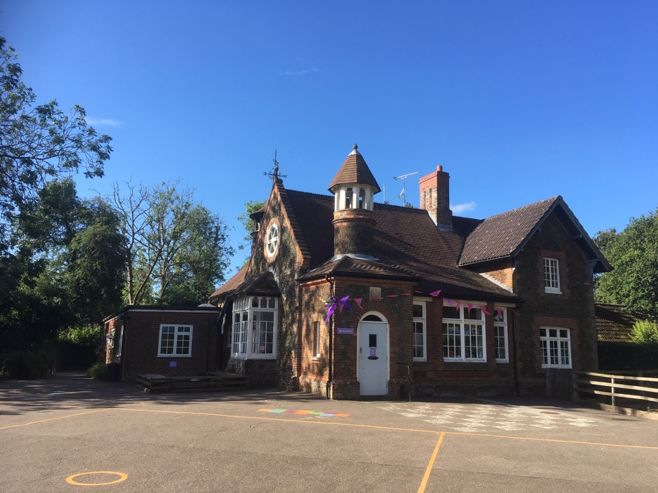

In January 2018 Ofsted inspected the Sandringham and West Newton Preschool, which received an outstanding grade in all areas. Ofsted stated:

- “Teaching is inspirational. All staff demonstrate teaching skills of the highest quality. They follow the children’s interests throughout the session and turn each activity into a high-quality learning experience that incorporates all areas of learning.

- The learning environment continuously captures children’s interest. It promotes their high levels of independence, engagement and creative thought.

- The atmosphere within the preschool helps them to develop high levels of concentration and depth of thought.

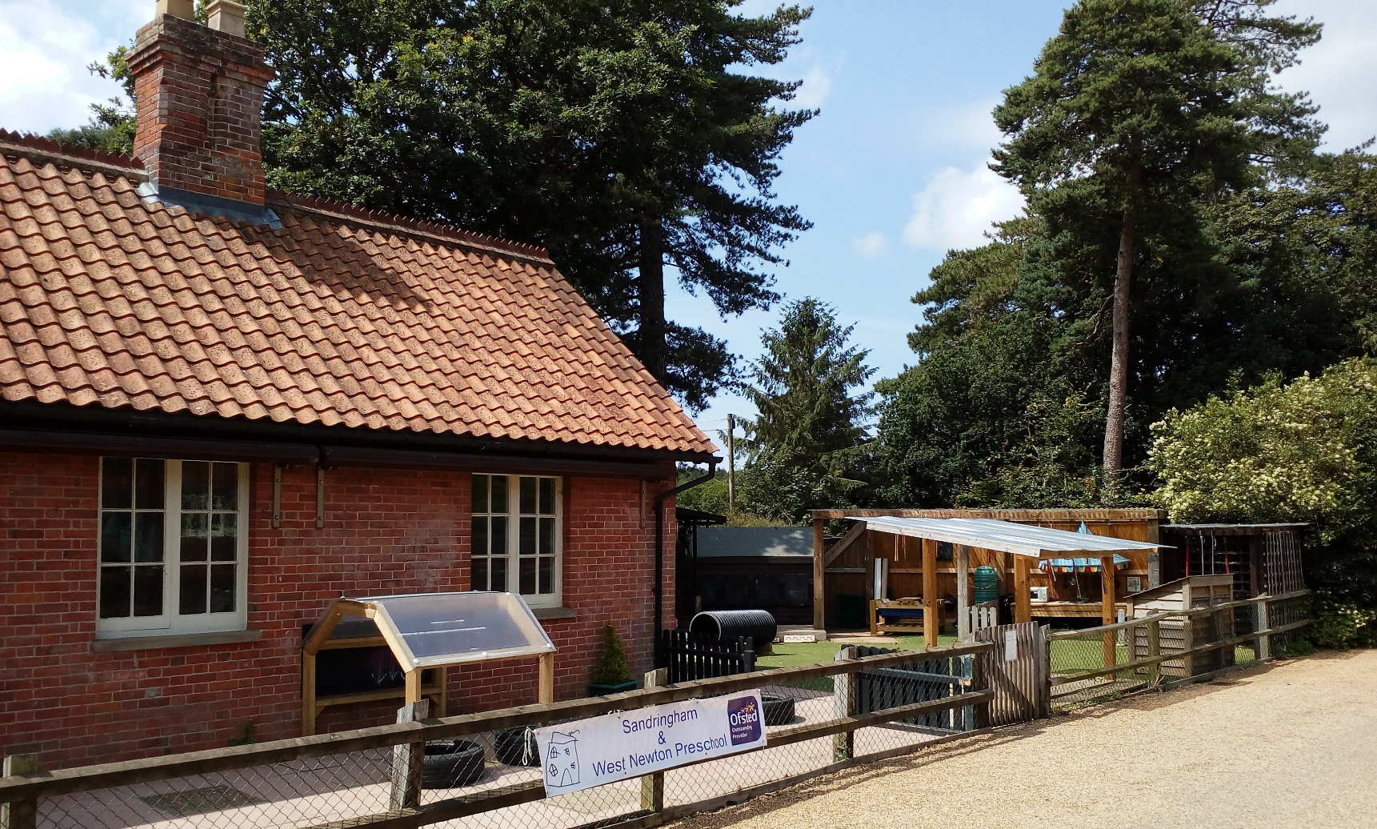

Sandringham & West Newton Preschool
The 3-4-year olds will be integrated into this Early Years provision, allowing them to make similar rapid progress but at an earlier age, ensuring high quality early intervention for all learners. Highly skilled practitioners, will ensure that in both settings Parents/Carers can recognise and access easily whilst knowing that their children will make at least good or better progress.

Objectives of the proposal?

- To ensure a high quality inclusive early years and foundation stage extended provision is available locally to the community and surrounding areas.

- To ensure free entitlement for eligible 3 and 4 year olds is available flexibly and extended through the school day to meet the needs of working parents.

- To ensure sustainability for the both settings by securing an increased intake and enhancing the links between both settings.

Will the proposed change result in any educational impact on the existing primary school provision?

We have conducted a thorough assessment of the resources needed and effects on the existing settings and we do not see that there will be any adverse impact on any existing level of provision. Both settings will work together to successfully manage this change. The provision in the afternoon sessions at Sandringham and West Newton Primary Academy will use the existing Reception class/outdoor area and the new building. Through discussions between both settings it is believed that the increased provision will have a positive impact on the local community.

Will the proposed change result in additional traffic near the school at drop off and pick up times?

The morning nursery sessions at the Preschool will begin at 9.00am and finish at 12.00pm with the afternoon session running at 12.30 to 3.30pm at Sandringham and West Newton Primary Academy . Supervised transport on foot between the two sites, will be provided by the two settings to cover the period between 12.00 and 12.30pm. We envisage no specific increase in additional traffic.

What will the impact be of providers of nursery provision locally?

The proposed increase to linked afternoons, thereby increasing the local offer to 30 hours free education for children of 3- and 4-year olds is not expected to impact on any other local provision as there is very little provision in the local area.
The proposal is therefore likely to have a little to no impact on other providers in the medium to long term.

How can you ask questions, get more information & comment on the proposal?

If you have any questions, please contact either setting on the details at the top of this letter. If you wish to make a response to this consultation, then please email on the addresses above or alternatively write to either setting at the addresses provided above. We will be allowing 4 weeks for receiving responses, so all responses must be received by 12pm on September 27th 2019 to be considered by the Governing Body when making its decision.

