Welcome to Class 1 /2

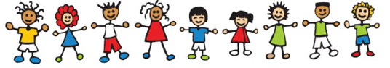

We have had a lovely time getting to know your little ones this week. We are all very excited to be back and get started on what we hope will be an exciting year!
Please feel free to come in and ask any questions about anything you need to know… but to make things a little easier, here’s some useful information.
Spellings
Each week your child will have new spellings to learn. We will have a test in school on Fridays.
Homework
Homework will be sent home on a Friday and returned on a Tuesday.

Reading
Please read with your child each night and then write a short comment in their reading record. Your support is greatly appreciated. We aim to read with your child at twice a week in school.
Forest Schools
We will have a Forest School session on a Thursday each week. Please can your child come dressed in appropriate clothing (jogging bottoms, jeans, sweatshirt, coat, hat, wellies) and bring their uniform to change in to.
PE Days
Our PE day is Tuesday.
Please ensure long hair is tied back and earrings have been removed.
Thank you
Here’s a checklist of things your child will need to have in school every day
- Book Bag
- Water bottle
- PE kit (t-shirt and shorts)
- Coat
- Sun hat / hat (weather dependent)
- Trainers (for the daily mile)
Please make sure that every item your child brings into school is named.

