Class 1 /2 Spring Term Newsletter

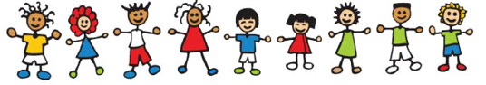
Happy New Year! We hope you all had a lovely Christmas holiday. May I take this opportunity to thank you for the lovely gifts I received, they were greatly appreciated.
We are all excited to be back and looking forward to a busy term of learning and fun!
This term our topic is ‘Around the World’. We will learn about the seven continents of the world and about some famous explorers.
PE Days
This term we will have PE on Tuesday and Wednesday each week.
Please ensure long hair is tied back and earrings have been removed.
Thank you
Reading
Please read with your child each night and then write a short comment in their reading record. Your support is greatly appreciated. We aim to read with your child at least once a week in school.
Forest Schools
We will have a Forest School session on a Thursday each week. Please can your child come to school wearing appropriate clothing (jogging bottoms, jeans, sweatshirt, coat, hat, wellies) and bring their school uniform in a bag to change in to.
Homework and Spellings
Homework will be sent home on a Friday to be returned by the following Wednesday.
Please continue to practise spellings at home each week. We will have a test in school on a Thursday.
Library Books
Your child may borrow a fiction and a non-fiction book each week to enjoy reading at home. We aim to change books on a Thursday each week.

