January 2020
Dear Parents and Carers,

Welcome back! I hope that you enjoyed the Christmas festivities and had a restful winter break, ready to embrace the challenges of a new decade, new year and our Spring term.

Our topic learning will focus on The Second World War and will link to our English where the children will be studying ‘The Lion and the Unicorn’ by Shirley Hughes. Our study of this book will focus on the theme of courage which is also the Christian value for this half term. I am incredibly proud of the progress that the children are making with their writing and hope that they will continue to develop their authorial flair in the spring.
Again, I would also like to impress the importance of reading at home and will continue to give the children the opportunity to gain raffle tickets to win a book voucher if they read to an adult 4 times per week.
We will also be becoming experts in types of rocks and soil profiles as we learn about ‘Rocks and Soils’ in Science. If you know anyone that is an expert in this area or has an exciting rock collection then do come in and let me know.
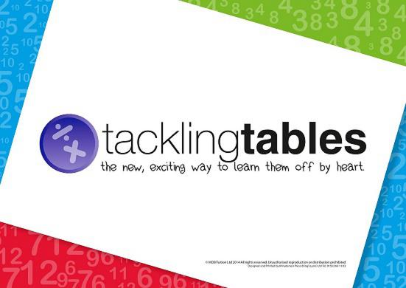
As ever, it is important for the children to continue to practice their times tables. Many children made a super effort during the Autumn Term and this was reflected in the number of children that moved through phases in Tackling Tables, keep up the hard work! Remember, all the children have a log-in to the Tackling Tables App and are welcome to log-in and practice any time. If there are any problems with these do not hesitate to come in and let me know.

In Maths, we will continue to practise using the four operations (+, -, x, ÷) to solve calculations as well as looking at shape, space and measure and beginning to think more carefully about reasoning and problem solving which can be tricky as it requires the children to think in stages.
Forest Schools and PE continues will be on alternate Thursday afternoons and Mrs Patnell will teach PE and Music on a Wednesday afternoon. Please remember to have PE kit, trainers and wellies in school at all necessary times. You are welcome to leave them in the cloakroom.
Homework will be set on a Friday to hand in on the following Tuesday (this differs from the previous year) and the children will be tested on their spellings each Friday; they will have a separate spelling book to allow them to practice throughout the week.
If you have any questions or concerns, do not hesitate to make an appointment to come and see me.
With kind regards,
Mrs King and Mrs Massen

