Friday 27th March 2020
Good morning Year 1 and 2! We have made it though our first week! The glorious sunshine has certainly helped! I have loved hearing from you and seeing pictures of all the lovely things you have been doing. Thank you!
A creative challenge for you today. Can you produce some handprint animal art?

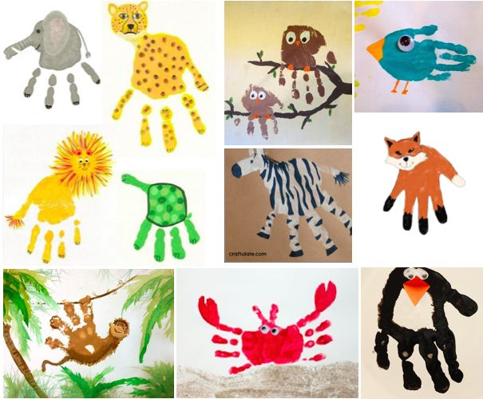
You could use paint or draw round your hand and colour it in. Also include extra details to create a habitat for your animal. Think about our work in science on the different world habitats.
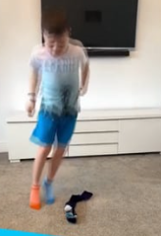
Today’s physical challenge is ‘Speed Bounce’! Simply lay a sock on the floor and jump over from side to side. How many bounces can you do in 20 seconds? Have a rest and then try again. Can you beat your score?

Don’t forget to email me, mgibson@swn.dneat.org
I would welcome any feedback regarding this week. This is all new to me too!
Have a good day!
Mrs Gibson

