Monday 30th March 2020

Good morning Year 1 and 2! I hope you have all had a good weekend. This week would have been our last few days so I will email you on Monday, Tuesday and Wednesday this week.

Today’s physical challenge is circuits! Think of 4 different activities, for example, star jumps, jogging on the spot, squats, leg raises, press ups. Create a circuit of the activities you have chosen and spend 30 seconds on each activity before moving on to the next. How do feel after completing the circuit? What changes to your body have you noticed?

Spread some joy! This week’s theme is sunshine. Draw, paint, colour or collage a happy sun picture to place in your window to make someone smile!
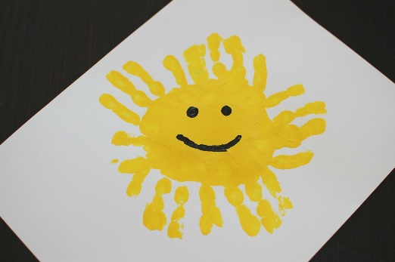

Parents, I would like to put some of the photographs you have sent to me on the school website. If you would prefer me NOT to include them please let me know.
Thank you

Don’t forget to email me, mgibson@swn.dneat.org

Have a good day!

Mrs Gibson

