Monday 23rd March 2020

Dear Year 1 and 2,
Today is the first day of our home learning journey, something new to us all. I have outlined this weeks learning in the weekly plan. There is no set timetable to follow, it is up to you when you do the activities. Each week I will send you details of the weeks learning and I will also email every day to check in. I would love to hear about the activities you have been doing at home. You can email me at mgibson@swn.dneat.org

PE
Why not start the day with some exercise. Tune in to Joe Wicks PE lesson live on YouTube at 9am every day.
https://www.youtube.com/channel/UCAxW1XT0iEJo0TYlRfn6rYQ

Get Arty
I have seen a lovely idea on Facebook over the weekend of placing a rainbow in a window of your house to spread joy to others. I challenge you to create your own rainbow picture. Here is ours! Don’t forget to send me a picture of yours!
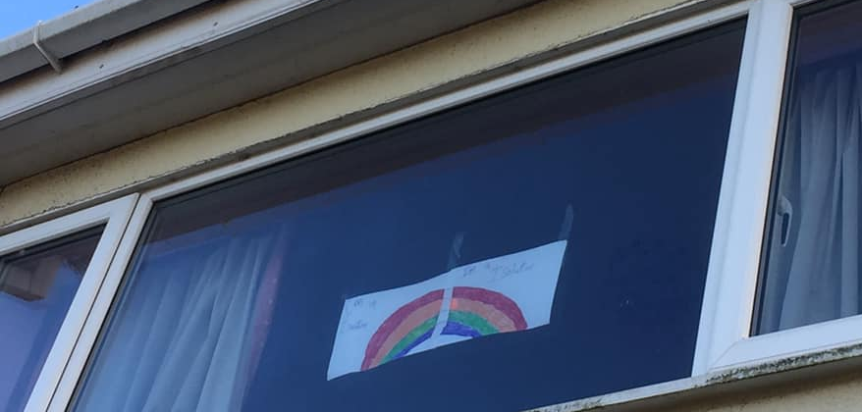

If you have any queries please feel free to email me.
Enjoy your day!

Mrs Gibson

