Thoughts for Friday 27th March 2020
“You cannot change the circumstances, the seasons, or the wind, but you can change yourself. That is something you have.” – Jim Rohn

As previously mentioned, I have outlined details for PE, English and Maths in my weekly plan. There is no set timetable for doing these things as it is important that you find a structure that works for you and your families.

Maths – Reflect on telling the time. How have you moved forwards from your starting point? Can you confidently tell the time using a digital and analogue clock.

English – Write a reflection on the week. I have attached an example of the types of things that you might consider.

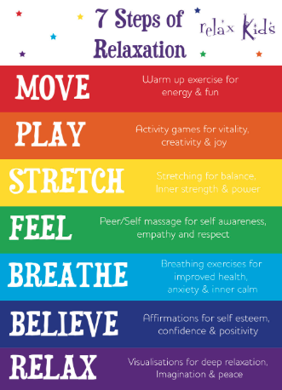
Mindfulness – Adding a few minutes of mindfulness to each day might take some of the stress out of redefining the routine. Today, try some relaxation techniques.

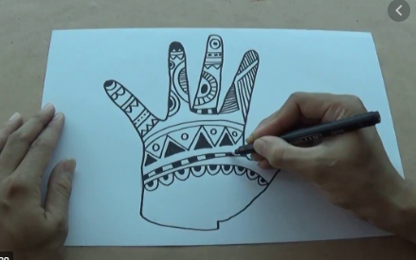
Art – Research Zentangles. Create a zentangle picture. This should be both fun and relaxing. I would love to see the art works you create.
You could design one for the first letter of your name.

I’d love to see how you are getting on. Email me at hos@sandringhamwestnewton.norfolk.sch.uk

Have a lovely day!

Mrs King

