Thoughts for Monday 23rd March 2020
“Happiness can be found even in the darkest of times if only one remembers to turn on the light”
Albus Dumbledore, Harry Potter Series

I have outlined details for PE, English and Maths in my weekly plan. There is no set timetable for doing these things as it is important that you find a structure that works for you and your families.

Spread some joy - On Facebook, I have seen many people joining in with a trend of painting pictures to put in their windows for children to spot when they go for a walk. This might be something nice to join in with. The theme for this week is ‘Sunshine’. Your challenge is to create a sunny image to pop into your window that may make someone else smile. You could colour it, paint it, print it, collage it etc. Send me a picture of yours!

Steel Pans – To finish off our music for the term. Create a fact file about steel pan music. Record 10 facts from research of that you can remember. Did you enjoy learning to play this instrument?

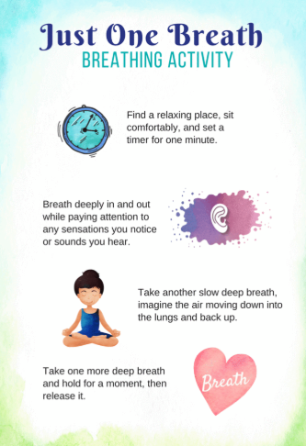
Mindfulness – Adding a few minute of mindfulness to each day might take some of the stress out of redefining the routine.

History – We have also now reached the end of our World War II topic. Choose a way to demonstrate what you have learnt. You could design a poster, write a list of facts, have a conversation with someone else at home about the things you now know, write a poem, make a mind map. Be creative! You could work on this throughout the week.

If you have any queries, email me hos@sandringhamwestnewton.norfolk.sch.uk

Have a lovely day!

Mrs King

