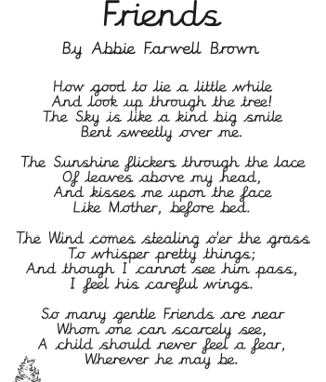
Thoughts for Tuesday 31st March 2020
“You’re mad. Bonkers. Off your head…I’ll tell you a secret…All the best people are.”
Lewis Carroll, Alice and Wonderland

I have outlined details for PE, English and Maths in my weekly plan. There is no set timetable for doing these things as it is important that you find a structure that works for you and your families.

Maths – Here is a link to some games that are accessible on a tablet of computer for practicing measurement https://www.topmarks.co.uk/maths-games/7-11-years/measures

Handwriting – Have a look at the poem to the write. Copy it out in your most beautiful cursive handwriting and decorate it.
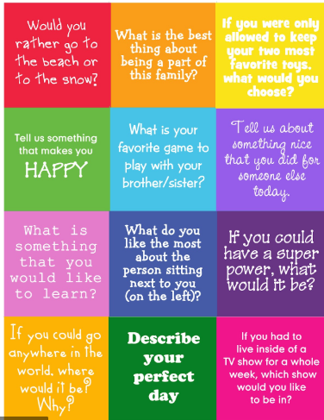
Spread the Joy – Choose one of the boxes to discuss with a family member or write about.

RE – We have been learning about the holy trinity – The Father, The Son and The Holy Spirit
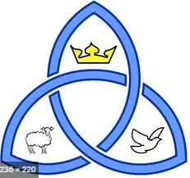
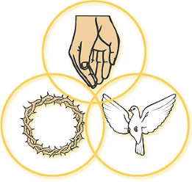
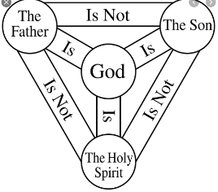
Create a symbol that you think represents them. I have included a couple of examples below;

Let me know what you think so far. I welcome feedback about how things are going. hos@sandringhamwestnewton.norfolk.sch.uk
Have a lovely day!

Mrs King

