Thoughts for Wednesday 1st April 2020
“I don’t understand it any more than you do, but one thing I’ve learned is that you don’t have to understand things for them to be.”
—Madeleine L’Engle, A Wrinkle in Time

As previously mentioned, I have outlined details for PE, English and Maths in my weekly plan. There is no set timetable for doing these things as it is important that you find a structure that works for you and your families.

Maths – Don’t forget to log on to Tackling Tables and practise for at least 15 minutes. Remember that as well as test mode you can also use learn mode and play mode. Learn and play modes will enable you to practise without racing against the clock. Any of you with Tackling Tables cards could practise using those as well.

English – Choose a picture from http://www.pobble365.com/. If you scroll below the enlarged picture, there are lots of ideas for how to use the picture in a creative way. I would love to see anything that you come up with.
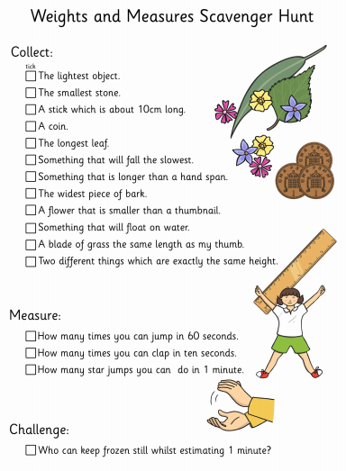
Scavenger Hunt – Whilst you’re enjoying the outdoors tomorrow, have a go at this weights and measure scavenger hunt.

Science – Earlier in the year we learnt about Teeth and Digestion. It is always useful to revisit previous learning.
How much can you remember? I have attached a Knowledge Organiser that outlines the information that we covered.
If your learning has been going in a different direction, let me know that too! I’m really enjoying seeing your pictures.
Let me know what you think so far. I welcome feedback about how things are going. hos@sandringhamwestnewton.norfolk.sch.uk

This will be my last daily learning email until after the Easter holidays. Have a lovely day!

Mrs King

