Thoughts for Monday 23rd March 2020
“You are braver than you believe, stronger than you seem, and smarter than you think.”
Christopher Robin, Winnie the Pooh

I have outlined details for PE, English and Maths in my weekly plan. There is no set timetable for doing these things as it is important that you find a structure that works for you and your families.

Spread some joy - On Facebook, I have seen many people joining in with a trend of painting pictures to put in their windows for children to spot when they go for a walk. This might be something nice to join in with. The theme for this week is ‘Rainbows’. Your challenge is to create a rainbow to pop into your window that may make someone else smile. You could colour it, paint it, print it, collage it etc. Send me a picture of yours!

Steel Pans – We should be doing our steel pan assembly today. Instead, your challenge is to listen to some steel pan music from Dover High School Steel Drum band.

https://www.youtube.com/watch?v=woBZME7sN3E
https://www.youtube.com/watch?v=dAK3jHan8J8
https://www.youtube.com/watch?v=6J3X0whM_-4 (This one really demonstrates the rolls you were learning well.)

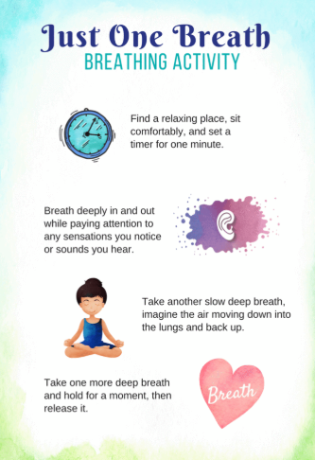
Mindfulness – Adding a few minute of mindfulness to each day might take some of the stress out of redefining the routine.

History – Morse code was used to send messages discreetly during World War 2. Research ‘Morse Code’ and have a go at preparing and sending a message. If you did this as part of your previous home learning can you remember how to send the message you prepared?

If you have any queries, email me hos@sandringhamwestnewton.norfolk.sch.uk

Have a lovely day!

Mrs King

