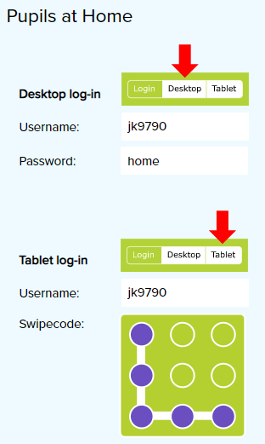
Thoughts for Tuesday 24th March 2020
“If you have good thoughts they will shine out of your face like sunbeams and you’ll always look lovely”
Roald Dahl, The Twits

As previously mentioned, I have outlined details for PE, English and Maths in my weekly plan. There is no set timetable for doing these things as it is important that you find a structure that works for you and your families.

Maths – Here is a link to a game that is accessible on a tablet for practicing telling the time. https://mathsframe.co.uk/en/resources/resource/116/telling-the-time

Handwriting – Have a look at Letter-join. See picture for log in details. There are lots of different resources to have a look at. Spend some time exploring and choose one thing to do. Resources>>Printouts>>Key Stage Two has some interesting options.
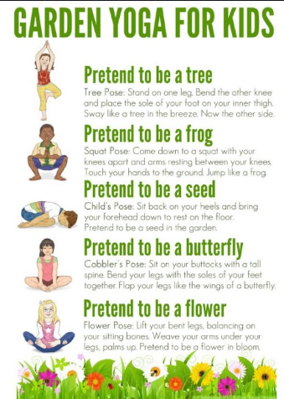
Mindfulness – Adding a few minutes of mindfulness to each day might take some of the stress out of redefining the routine. Today, try some yoga.

RE – In RE, we have been learning about the holy trinity. In this week’s lesson, we were going to make some salt dough. Flour for God the father (white is pure), salt for God the son (Jesus brought flavour to life) and water for the Holy Spirit (water is a symbol of spirit in the Bible) – three ingredients – mix together to make something different from all of the parts, but containing all. The trinity, made from a trinity of ingredients.
Option 1: Have a go at making some salt dough. You could make a tile picture of the baptism of Jesus.
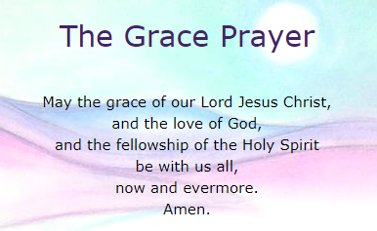
Option 2: Create a poster of the school ‘Grace Prayer’ using your neatest handwriting. This mentions the holy trinity.

Let me know what you think so far. I welcome feedback about how things are going. hos@sandringhamwestnewton.norfolk.sch.uk

Have a lovely day!

Mrs King

