Thursday 26th March 2020

Good morning Year 1 and 2!
Well do to everyone who completed the 60 second challenge yesterday. The award winners are:
Chloe | Zalia  Jaime  Sophia | Emily

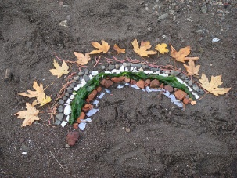
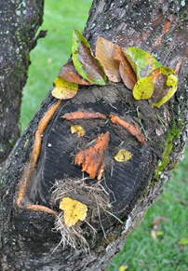
Thursday is Forest School Day! Try to find some time today to complete a forest school activity outside. You could go on a bug hunt, build a den for a small animal or create a picture using things you can find.

On Thursday’s we usually complete our Tackling Tables challenges.
Year 2s, log onto the Tackling Tables website and complete a test. If you need a reminder of your log in details just email me.
Year 1s, keep up your mental maths skills by playing the ‘Daily 10’ on Topmarks. Just select level 1, choose addition or subtraction and then how long you would like the intervals to be.
https://www.topmarks.co.uk/maths-games/daily10 This game is suitable for all children.
Another good game to practise number bonds and times tables is ‘Hit the Button’. https://www.topmarks.co.uk/maths-games/hit-the-button

Today’s physical challenge is ‘Spell Your Name PE’!
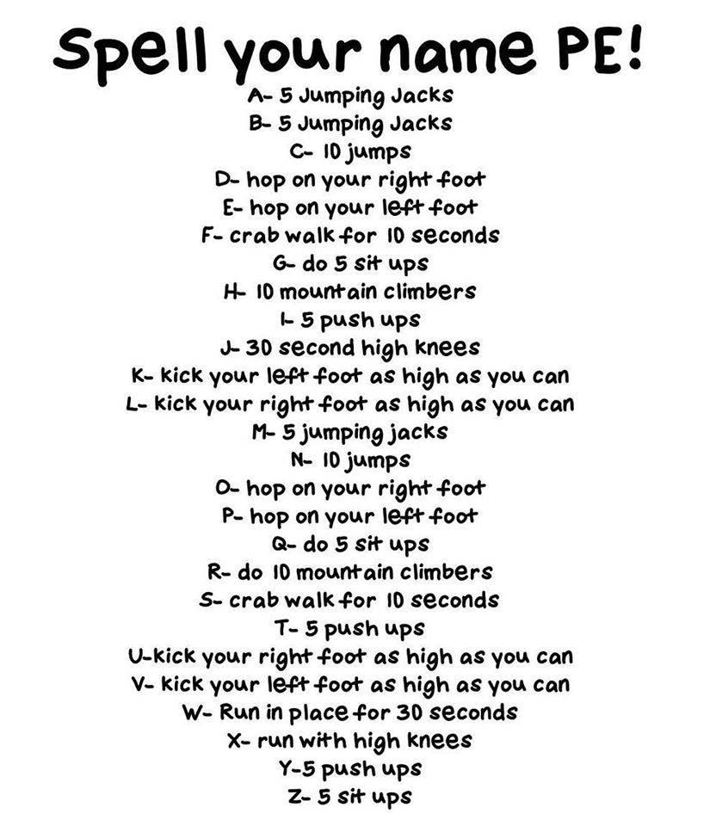
I have really enjoyed receiving your emails and hearing about the things you have been doing. Miss you all and hope you are keeping safe.
Don’t forget to email me, mgibson@swn.dneat.org

Enjoy your day!

Mrs Gibson

