Wednesday 1st April 2020

Good morning Year 1 and 2!

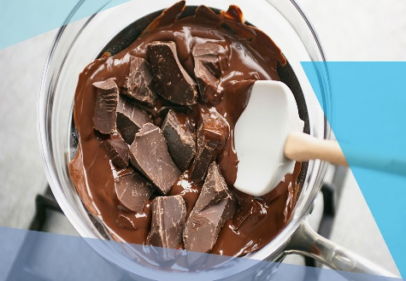
A bit of science today! I would like you to look closely at a piece of chocolate, what does it look like? How would you describe it? Now I would like you to melt it. How are you going to melt it? What makes the chocolate melt? Observe the changes to the chocolate, what words would you use to describe it now? Now think about if we can change the chocolate back to what it was like at the start, is it a reversible or irreversible change?

Today’s physical challenge is called ‘Active Story Time’! It is a great way to revise verbs and adverbs too. Remember the game we played in school ‘walk quickly’, ‘crawl slowly’ etc. Details can be found on the next page.

I would love to hear all about your day, mgibson@swn.dneat.org

Have a good day!

Mrs Gibson

Today’s physical challenge is ‘Story Time’!
