Wednesday 25th March 2020

Good morning Year 1 and 2!
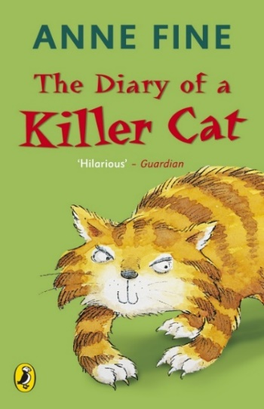
Our class reader has been ‘The Diary of a Killer Cat’. Sadly, we didn’t get to finish it before we finished school. I have found a YouTube video of someone reading the last chapter. Tell your grown up what has happened so far in the story. What has Tuffy the cat done? How do the family feel about it? What do you think will happen next?
The link to chapter 7 is https://www.youtube.com/watch?v=pZktD1SSqjw

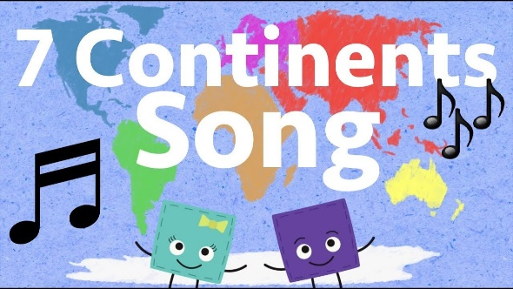
The Continents song on YouTube has been a favourite in class when we have been learning about the continents.
https://www.youtube.com/watch?v=K6DSMZ8b3LE

If you like to keep active try the 60 second challenge on the next page. Let me know if you achieve gold, silver or bronze and I will send you a certificate!

I have really enjoyed receiving your emails and hearing about the things you have been doing. Miss you all and hope you are keeping safe.

Don’t forget to email me, mgibson@swn.dneat.org

Enjoy your day!

Mrs Gibson

