Dear Year 3 and 4,
We are now embarking on our second week of home learning and this new way of doing things will be a change for all of us.
This document outline suggested activities for English, Maths and PE for the week but I will also be in touch daily to check in, pose questions to think about and provide some activities focussed on our foundation subject learning.

Week commencing 30th March 2020
Daily Activities
PE
- At 9:00AM Monday-Friday, Joe Wicks is doing a 30-minute live daily PE lesson. Details to log on; https://www.youtube.com/channel/UCAxW1XT0iEJo0TYlRfn6rYQ
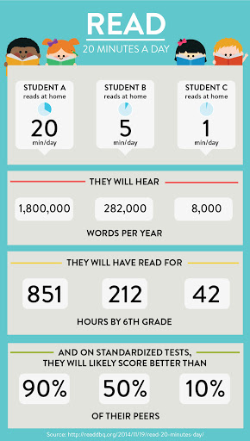
English
- Reading – Try to read for at least 20 minutes each day. Think of how many books you would get through and how many new words you would learn.
- Choose 1 comprehension activity from your book. The answers are that the back of the book so you could self-mark or ask your parents/older siblings to help you.
- Write 1 thing each day –Lists/poems/stories/sentences/recipes/instructions/
diaries/letters. I would love to see what you come up with.
- Spellings – I have sent home/attached the statutory spellings for year 3 and 4. Practise 3 or 4 each day and gaining confidence with spelling them will make a huge difference!
- Handwriting – Don’t forget that you can log on to Letter Join if you would like to access any of the handwriting resources.
Maths
- Times tables – Everyone should have their Tackling Tables log-in details. I can email them to anyone that is unsure. The children that were in school last week use the website more than usual and their practise definitely made a difference to their score. Everything is set up so that I can see how you are getting on at home.
- Number of the Day – We do this at school every day. I have attached the sheet that the children usually get. Daily practice of arithmetic skills will be really helpful for the children when they return to school.
- Theme of the week: Measuring – Can you measure to bake something? Do you know the difference between length, weight and capacity? https://www.bbc.co.uk/bitesize/topics/zcpnb9q These BBC Bitesize clips may come in useful.

In my daily emails, I will provide details of ways to consolidate and enhance learning in subjects such as Science, History, Geography, RE, Computing, Art and Design, French, PSHE and Music. I will try to make these as straight forward and as home-friendly as possible. Equally, if there are ideas that come from conversation and the children wanting to take learning in their own direction, this should be encouraged. I am trying to look at this with a positive mind set and therefore I am of the view that it is an opportunity to explore and develop their own interests also.

I have loved seeing pictures of how you are getting on at home. Keep sending them and also do get in touch of you have any queries. My email address is hos@sandringhamwestnewton.norfolk.sch.uk

I look forward to hearing from you.

Mrs King

