Dear Year 3 and 4,
We are now embarking on our first week of home learning and this new way of doing things will be a change for all of us.
This document will outline some suggested activities for the week but I will also be in touch daily to check in, pose questions to think about and provide some additional suggestions.
Week commencing 23rd March 2020
Daily Activities
PE
- At 9:00AM Monday-Friday, Joe Wicks is doing a 30-minute live daily PE lesson. Details to log on; https://www.youtube.com/channel/UCAxW1XT0iEJo0TYlRfn6rYQ
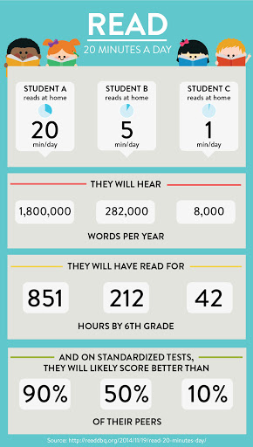
English
- Reading – Try to read for at least 20 minutes each day. Think of how many books you would get through and how many new words you would learn.
- Choose 1 comprehension activity from your book. The answers are that the back of the book so you could self-mark or ask your parents/older siblings to help you.
- Write something each day –Lists/poems/stories/sentences/recipes/instructions/
diaries/letters. I would love to see what you come up with.
- Spellings – I have sent home/attached the statutory spellings for year 3 and 4. Practising a few of these each day and gaining confidence with spelling them will make a huge difference!
- Handwriting – Don’t forget that you can log on to Letter Join if you would like to access any of the handwriting resources.
Maths
- Times tables – Everyone should have their Tackling Tables log-in details. I can email them to anyone that is unsure. The children that were in school last week use the website more than usual and their practise definitely made a difference to their score. Everything is set up so that I can see how you are getting on at home.
- Number of the Day – We do this at school every day. I have attached the sheet that the children usually get. Daily practice of arithmetic skills will be really helpful for the children when they return to school.
- Theme of the week: Telling the time – Can you tell the time using a digital clock? An analogue clock?
In my daily emails, I will provide details of ways to consolidate and enhance learning in subjects such as Science, History, Geography, RE, Computing, Art and Design, French, PSHE and Music. I will try to make these as straight forward and as home-friendly as possible. Equally, if there are ideas that come from conversation and the children wanting to take learning in their own direction, this should be encouraged. I am trying to look at this with a positive mind set and therefore I am of the view that it is an opportunity to explore and develop their own interests also.
It would be great to see how you get on, feel free to email pictures of the learning you are completing or the way that you are spending your time. My email address is hos@sandringhamwestnewton.norfolk.sch.uk
I look forward to hearing from you.
Mrs King

