Easter Holiday Ideas
Hi, Year 1 and 2
This will be my last email until after Easter. I found some lovely Easter activities that I thought I would share with you. You do not have to do them but, as always, I would love to see what you get up to! mgibson@swn.dneat.org

Salt Dough Easter Eggs
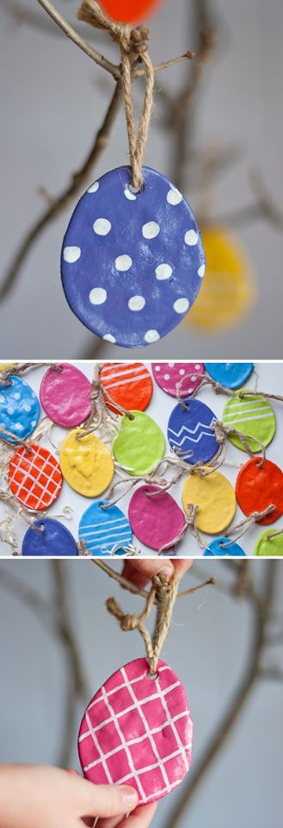
Mix up your favourite salt dough recipe.
1 cup flour
1/2 cup salt
1/2 cup water
Stir together all three ingredients until a dough forms. Kneading the dough a couple times can help make it smoother.
Roll it out and cut out desired shapes.
Place the salt dough Easter eggs on the parchment-covered ?? baking sheets. Remember to make a hole so you can hang the ornaments — a straw works perfectly!
Bake at 250F for 2 hours.
Once the shapes are adequately baked, dried and then thoroughly cooled, it’s painting time
Optional: To further protect the colour and design, add a clear coat sealer.
Loop twine or ribbon through the holes and hang. 🐣🐣🐣🐣🐥🐥🐥🐥🐥🐥🐥🐥🐥🐰🐰🐰🐰🐰🐰🐰

Spread the joy!
If you would like to continue to spread some joy to people who walk past your house, then colourful Easter eggs is the theme for next week.

Easter Bonnet Parade
I challenge you to design and make an Easter hat. You could make a hat out of paper/card or use a hat you already have and add decorations to it. Send me a photo of your creation and I will put them on the school website for an Easter Hat Parade!

Reading
I hope that many of you will keep reading during the holiday time. So, to make it more interesting I challenge you to find the most unusual place in your home/garden to read your book. Let me know where you find!
Try Something New
At school one of our Personal Development attributes is to try something new. So, over the next couple of weeks I would like you to try something that you have never done before. It could be anything but here are a few ideas to get you thinking.
yoga | sewing | magic tricks
dance | woodwork | photography
Let me know what you try so that I can tick it off your sheets and you will have made a start towards your Bronze badge!

Active Bingo
I know lots of you have enjoyed the daily physical challenges so here are lots of ideas to keep you busy!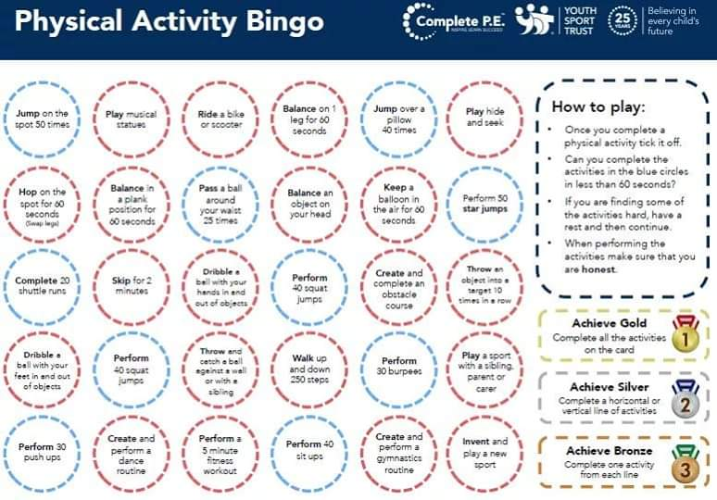

Hope you all have a lovely, if different, Easter break!
Mrs Gibson

