Home Learning W/Beg: 20/4/20
Welcome back! Hope you all had an enjoyable Easter break. This week’s learning has a spring theme, so fingers crossed for a week of lovely weather. Please keep the photos coming in and let me know what you have been up to.
Hope you have a good week! mgibson@swn.dneat.org

English
Spring List  Go on a walk (in your garden or as part of your daily exercise). Look out for signs of Spring. Think about the plants and animals you can see and hear. When you return home write a list or draw pictures of the things you saw. | Spring Adjectives  Using your list of words and/or the pictures on the next page, think of some adjectives or simple noun phrases to describe the signs of Spring.  eg, bright, red tulips  playful, fluffy lambs | Spring Poem  Write a Spring acrostic poem using some of the words and adjectives you have been collecting this week. Each new line of your poem must spell the word ‘Spring’. Some examples are on the next page.
Year 2 English SATs book  Reading Fiction – Pages 38 and 39  Year 1 Comprehension Book  Colour the Picture and Can you finish it? Pages 12 and 13 | Spellings  Practise the common exception words for your year group. On Friday have a big spelling test of all the words. Let me know your scores!  https://spellingframe.co.uk/ a good website with free games to practise those spellings! | Reading  Remember to read for at least 10 minutes every day and continue to record reading in the reading diary.  Year 1 – Practise your phase 3 and 5 sounds every day and one page from your phonics book.

Spring Pictures – Can you think of some adjectives to describe these signs of spring? | Example of an Acrostic Poem
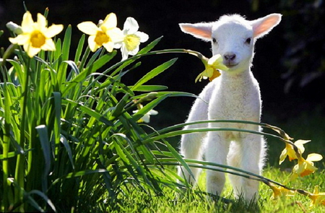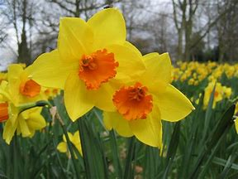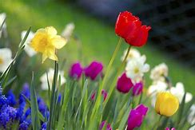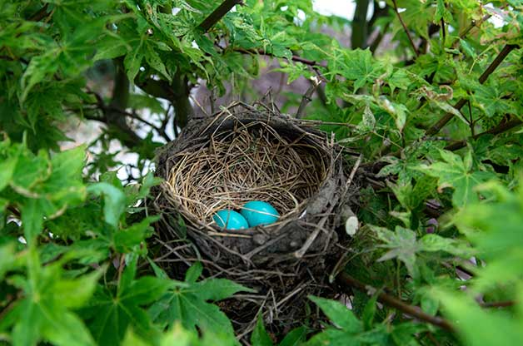  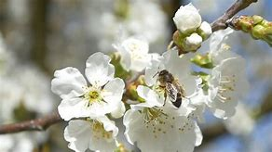 | Spring is here  Pretty flowers grow  Rain showers  Insects crawling  New animals are born  Golden sunshine  Sunshine and cool showers  Playful, fluffy lamps skipping  Rainbows fill the sky  In the flower’s bees are buzzing  Nests full of small, shiny eggs  Gorgeous flowers in bloom

This week we are trialling the use of the White Rose Maths home learning resources. On the website (link below) there is a short video clip to explain the content. There is a worksheet to go with it. I suggest that you have the worksheet open on the computer and write the answers on a separate piece of paper to save you printing out. Please let me know how you get on with these materials.

Year 2 Maths – Using White Rose Maths Home Learning Resources Summer Term Week 1
https://whiterosemaths.com/homelearning/year-2/
Lesson 1 – Finding ¾ | Lesson 2 – Count in Fractions | Lesson 3 – Measure Length (cm) | Lesson 4 – Measure length (m) | Lesson 5 – Maths Challenge

Year 1 Maths – Using White Rose Maths Home Learning Resources Summer Term Week 1
https://whiterosemaths.com/homelearning/year-1/
Lesson 1 – Make doubles | Lesson 2 – Make equal groups (grouping) | Lesson 3 – Make equal groups (sharing) | Lesson 4 – Find a half | Lesson 5 – Maths Challenge

Topic Work
Seasonal Change  Keep a weather chart this week. Record the weather and temperature each day. Remember to do it at the same time each day to keep it fair. At the end of the week complete the graph and discuss your findings. Think back to when we completed the autumn and winter weather charts in class, what changes, if any, have there been?  I have attached the weather chart we have previously used in class. | Micro-Habitats  This week I would like you to investigate a microhabitat – your garden! What animals or insects can you find in your garden? Keep a tally chart of your findings. | Bug Hotel or Bird Feeders  Think about how you can encourage insects, birds and animals to your garden. Maybe you could create a bug hotel or a bird feeder.  