Home Learning W/Beg: 27/4/20
Please keep the photos coming in and let me know what you have been up to. Hope you have a good week! mgibson@swn.dneat.org

English
Instructions  After you have planted your sunflower seeds, write a set of instructions to help someone else. Remember to include:  - Numbers  - Bossy words  - Precise sentences  - Adverbs (Eg. slowly, carefully, firmly) | Minibeast Factsheet  Choose a minibeast you would like to find out about. Research some facts about it. Think about what it looks like, where it lives, how it moves, what noise it makes and anything else! Produce a fact sheet about your chosen minibeast. | Minibeast Riddles  Write a riddle about a minibeast. Think carefully about the order of the clues you give to keep the reader guessing! An example is on the next page.
Year 2 English SATs book  Finding Meaning – Pages 40 and 41  Year 1 Comprehension Book  In the Park and Yes or no? – Pages 14 and 15 | Spellings  Practise the common exception words you did not know from last weeks big test. Pick no more than 10 to practise all week and then test on Friday.  https://spellingframe.co.uk/ a good website with free games to practise those spellings! | Reading  Remember to read for at least 10 minutes every day and continue to record reading in the reading diary.  Year 1 – Practise your phase 3 and 5 sounds every day and one page from your phonics book.

Example of an Animal Riddle
Who am I?

I have four thin legs and a long tail.
I like to eat long, juicy, green grass.
I am usually black and white but sometimes I can be brown.
You like to drink my milk.
You might hear me moooo!
What am I?

A cow!

Maths
This week we are trialling the use of the White Rose Maths home learning resources. On the website (link below) there is a short video clip to explain the content. There is a worksheet to go with it. I suggest that you have the worksheet open on the computer and write the answers on a separate piece of paper to save you printing out. Please let me know how you get on with these materials.
Year 2 Maths – Using White Rose Maths Home Learning Resources Summer Term Week 2
https://whiterosemaths.com/homelearning/year-2/

Lesson 1 – Compare Lengths | Lesson 2 – Order Lengths |  | Lesson 3 – Four operations with length | Lesson 4 – Problem Solving |  | 2 pages from your arithmetic maths book
Year 1 Maths – Using White Rose Maths Home Learning Resources Summer Term Week 2
https://whiterosemaths.com/homelearning/year-1/

Lesson 1 – Find a half | Lesson 2 – Find a quarter |  | Lesson 3 – Find a quarter | Lesson 4 – Problem Solving |  | 2 pages you’re your Addition and Subtraction booklets
Number of the Day  I have attached a number of the day sheet similar to what we use in class. Choose a random number and try to complete all the boxes about that number. |  | Sumdog  Last week I sent out login details for ‘Sumdog’. The activities are changed weekly and it is a fun way to practise maths skills. |  |  | Year 2 – Tackling Tables  Don’t forget to login to complete you Tackling Tables.  Well done to Emily for a great improvement this week and also to Lenny for practising every day.

Topic Work
Science - Seasonal Change  Continue to keep the weather chart this week. Record the weather and temperature each day. Remember to do it at the same time each day to keep it fair. At the end of the week complete the graph and discuss your findings. Think back to when we completed the autumn and winter weather charts in class,  what changes, if any, have there been? Write a couple of sentences to share your findings. | Science – Seeds  Plant your sunflower seeds and look after them over the next few weeks. Each week observe you plant carefully and keep a seed diary. Draw a picture each week and use a ruler to measure how tall it has got. | Science - Parts of a Plant  https://www.bbc.co.uk/bitesize/topics/zpxnyrd/articles/z3wpsbk  Draw and label the parts of a flowering plant. Use these words to help you label your picture  Leaves, flower, petal, roots, stem.
DT - Make a model of a minibeast  I know how much you all like junk modelling, so I challenge you to make a model of a minibeast using what you can find at home.  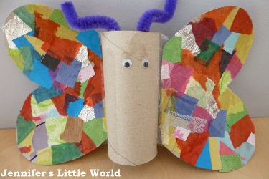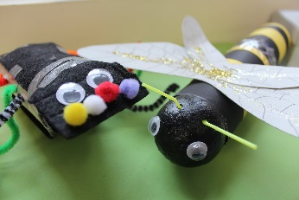 | Art – Sunflowers  ‘Sunflowers’ was one of Vincent Van Gogh’s most famous paintings. Do you like it? What do you like? How do you think he made it? Paint, pastels, drawing?  Create your own sunflower masterpiece using pens, pencils, paints, or chalk. | Music  This week I will be sending out children’s logins for the music website Charanga. The unit of work is called ‘Your Imagination’.

