The Ancient Greeks

The ancient Greeks were great thinkers, warriors, writers, actors, athletes, artists, architects and politicians.
The earliest Greek civilization lived nearly 4000 years ago. The ancient Greeks lived in Greece and countries that we now call Bulgaria and Turkey.
The ancient Greece empire spread over Europe as far as France, the Greek empire was most powerful between 2000BC and 146BC.
Ancient Greece was split into many different states, each one was ruled in its own way, each state had its own laws, Government and money but they all shared the same language and religion. The two most important city states were Athens and Sparta.
The influence of the ancient Greeks are still felt by us today in arts, philosophy, maths, science and literature.

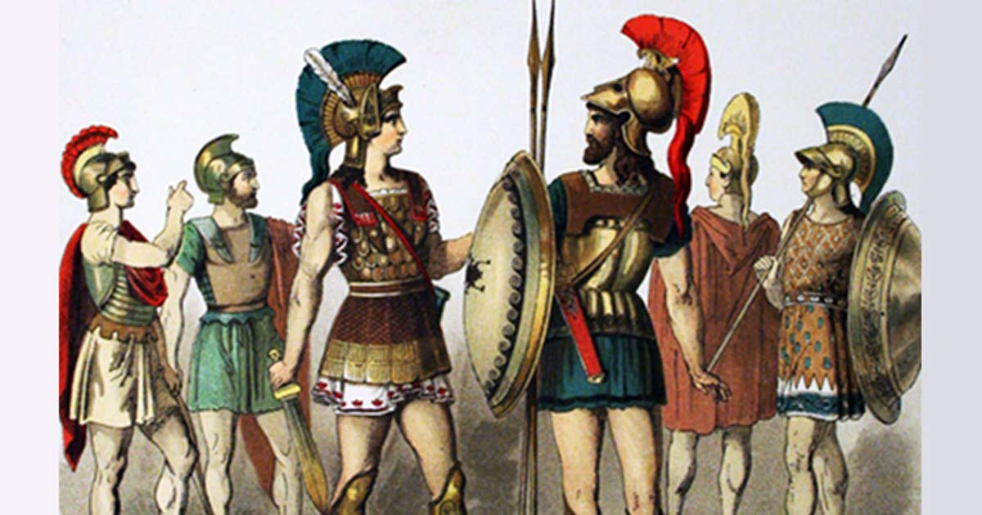

Democracy was very direct which meant all of the citizens voted on all of the laws, rather than voted for the representative like we do, there were 3 main types of government
. Democracy- a government ruled by people
. Monarchy- a single ruler like a king
. Oligarchy- When the government is ruled by a smaller group.
They did have officials to run the government but most of these officials were chosen by a lottery. In order to vote you had to be a citizen, only men who had completed their military training were counted as citizens.
Bodies of government were made up in three parts.

The Assembly, this was the citizens who showed up to vote and they decided on new laws and important decisions (going to war).

The Council this was the day to day running of the government, the Council was determined by the lottery.

The Courts this was were they handled lawsuits and trials, the courts had large juries to help make decisions.

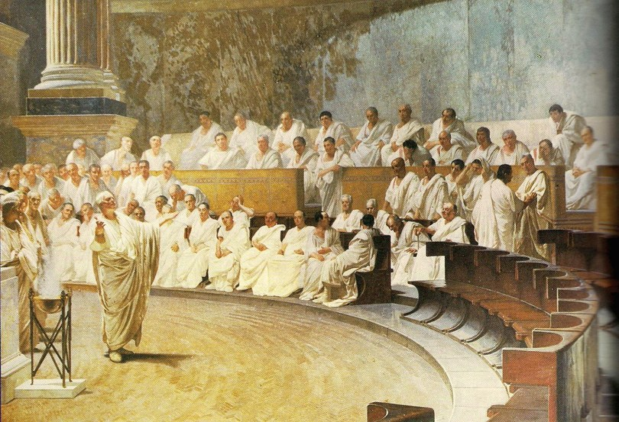

The ancient Greek Olympics began over 2700 years ago in south west Greece. Every 4 years, around 50,000 people came from all of Greece to watch and take part. This still happens now.
Ancient Greeks loved sport and in most cities, they had a public gymnasiums where people trained and relaxed. Most men and boys practised sports, sport was a good preparation for war too.
The Greeks had four national sports festivals, the most important of the contests was the Olympic games, these were played at Olympia every four years in honour of the God Zeus, On the first day of the Olympics, sacrifices of grain, wine, and lambs were made to Zeus. The first recorded ever Olympic games were in 776BC.
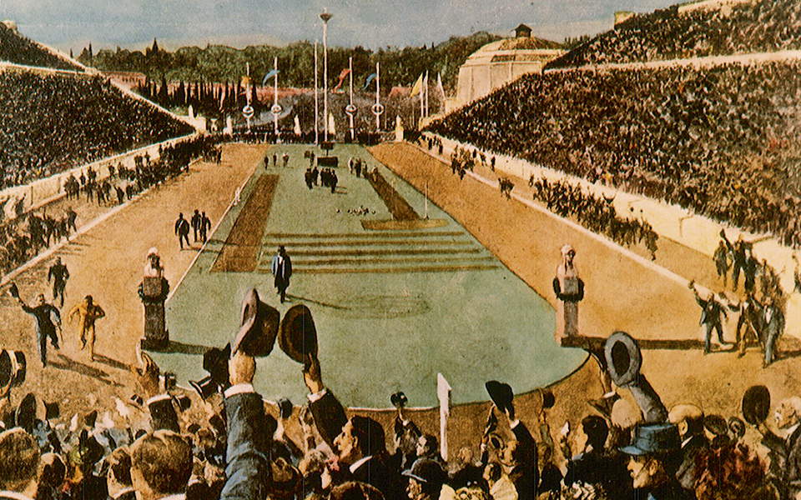

In 490 BC, the Persian navy sailed down the coast of Greece and stopped at the bay of Marathon which is about 40 miles north of Athens. The Athenian army moved to block the Persian’s advance and then trapped them on the plains around the bay, on the fifth day, the Greeks attacked. Athens was supported by a small force from the city of Platea. The battle was the end of the first attempt by Persia, under king Darius I, to conquer Greece. It was part of the first Greco- Persian war. The Persian invasion was a response to Greek involvement in the Ionian revolt. Then, Athens and Eretria had sent a force to support the cities of Ionia, who were trying to overthrow Persian rule. The Athenians and Eretrians succeeded in capturing and burning Sardis but were forced to retreat with heavy losses. In response to this raid, Darius swore to burn Athens and Eretria to the ground.
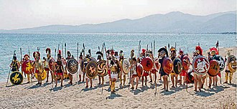

There are 12 Greek Gods and Goddesses; Zeus, Aphrodite, Hera, Poseidon, Demeter, Athena, Apollo, Artemis, Ares, Hephaestus, Hermes, Hestia.
The ancient Greeks believed in many Gods and Goddesses, the Gods and Goddesses had many human qualities, but they had many more powers than mortals and would live forever. The 12 most important gods and goddesses lived on Mount Olympus and they spoke about many things.
. Aphrodite was the goddess of love and fertility.
. Apollo was the god of the sun and music.
. Ares was the god of war.
. Artemis was the goddess of hunting.
. Athena was the goddess of war.
. Hades was the god of the underworld.
. Hephaestus was the god of fire.
. Hermes was the messenger of the gods.
. Dionysus was the god of vine.
. Zeus was the king of gods and goddesses
The temper of Zeus effected the weather.
Poseidon was the god of the sea and the brother of Zeus, he lived in a palace under the sea and his temper caused earthquakes.
Not all Greek gods and goddesses lived on Mount Olympus.
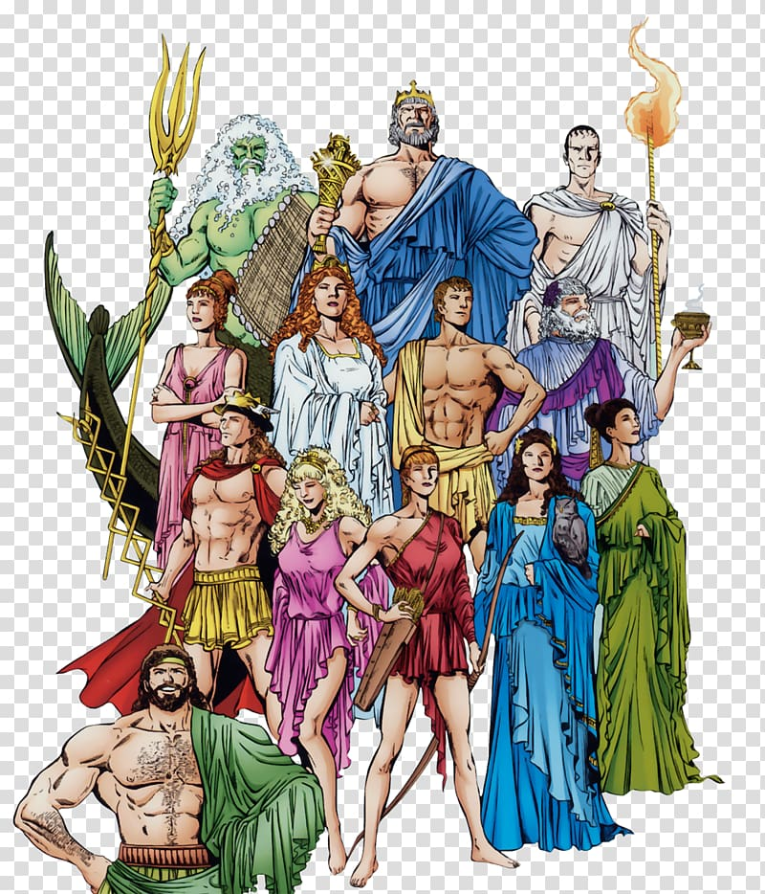
Hades the god of the dead lived in the underworld, people made sacrifices if they wanted something bad to happen.

The Trojan war was one of the greatest wars in history of ancient Greece, it happened between the trojans and the Achaeans.
The origins of the war started at the wedding of king Peleus and nereid(sea-nymph)Thetis. They had invited almost all the gods to their wedding, but they did not invite the goddess of Eris. She was angry so she threw a golden apple among the guests. The goddesses Hera, Athena, Aphrodite caught the apple at the same time and fought over who was the most beautiful. They went to Zeus the king of Gods, so he could choose who got the apple. Zeus chose Paris to decide and give the apple to who he wanted. Each of the three goddesses offered Paris gifts so he would choose her. Hera offered Paris all of Asia. Athena offered wisdom.
Then Aphrodite offered him the love of the most beautiful woman. Paris gave the apple to Aphrodite. Of course, Aphrodite had not thought about the fact that the most beautiful woman, Helen, Queen of Sparta, already had a husband (King Menelaus of Sparta). But Aphrodite had her son, Eros, shoot Helen with a golden arrow so she fell in love with Paris. They left for Troy. Menelaus, Helen's husband, declared war on Troy to retrieve his queen, now called Helen of Troy. This began the Trojan war. The war went on for ten years. The Greeks won by building a big wooden horse, which we now call the trojan horse.
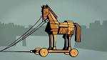
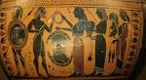

Kaden underwood

