Thursday 23rd April 2020

Good morning! Happy St George’s Day!
An extra challenge for the end of the week is to find out about St George, the patron saint of England.
This website has some good information for children. http://projectbritain.com/stgeorge.html
Can you draw, paint or make something to help celebrate this day?
Make a flag  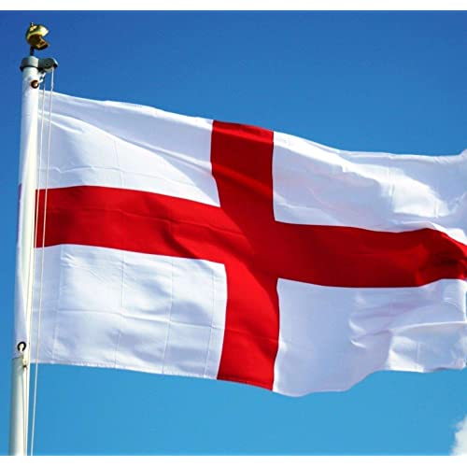 | A red rose
A dragon  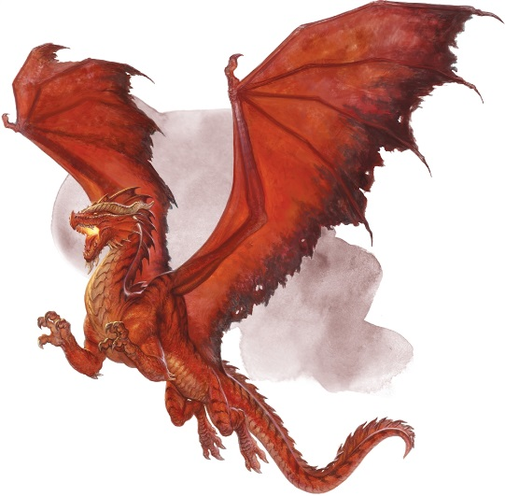 | A sword and shield  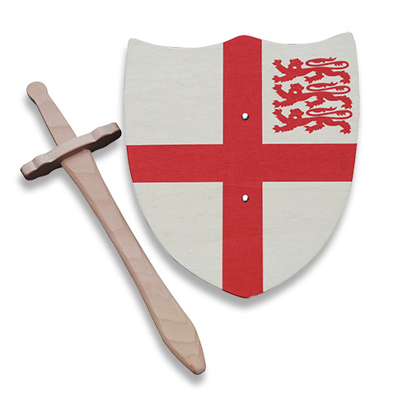

I can’t wait to see your creations!
Mrs Gibson
mgibson@swn.dneat.org

