Reading | Writing | Spellings | Maths  Theme for the week: Fractions | Curriculum
Read Online  Get your child to read a book on Oxford Owl, there are books for all ages and abilities. Sign in details below;  Username: Sandringham34  Password: Sandringham  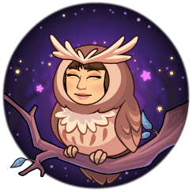 | Pobble Challenge  Complete a challenge from Pobble ‘Wild Horses’ (01/06). If you click on the PDF below the picture, it will give you a story starter and some other ideas. I think the sentence challenge on collective nouns looks interesting! | Common Exception Words  Continue you to work on learning to read and spell the Year 3 and 4 Common Exception Words. By the end of LKS2 you should be able to use these words confidently. | Tackling Tables  Use your log on to access Tackling Tables and practise in Learn, Play or Test mode | Be Active  Complete a daily workout following PE with Joe Wicks or have a go at some yoga. Check out Cosmic Kids Yoga
Explore Vocabulary  Explore new vocabulary you find when reading.  - Write down new words.  - Look them up in the dictionary  - Find a synonym or antonyms for your new word | Quick Fire Write!  Have a go at one of the Quick Fire Write challenges. These are writing prompts that you should respond to in 200-400 words and you can submit your final outcomes online.  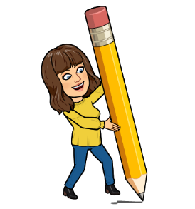 | Choose 10 Common Exception Words to focus on for the week.  Write a synonym, antonyms, the meaning and an example of how to use the word in a sentence. Can the word be modified? | Access Bitesize Daily Lessons. The theme this week is Fractions | Get Creative  JK Rowling has launched a competition that involves creating illustrations for her new book The Ickabog which she will be releasing chapters from online for children over the coming weeks. I know that many of you are JK Rowling fans so what are you waiting for? Get drawing!
Be A Reading Detective  Access Bitesize Daily Lessons and practice your inference skills so that you can become a reading detective. | Author Masterclass  If you are an aspiring author, take an Author Masterclass. It may take a few moments to sign up but the content is free and inspiring. The 10 minute challenges are great too! | Can you use 10 Common Exception Words in your Pobble Challenge task? | Measuring and fractions in practical context  Measure 1 litre. Discuss that is it also 1000ml. On your jug, identify half a litre and how much is this in ml?  How much is ¼ of a litre?  How much would you need to pour out of the jug to leave ¼ of a litre?  How much is ¾ of a litre – can you fill the jug that high?  How much water do different ‘vessels’ hold – mug, mall pot, etc.…ideally less than a litre.  Try to measure with accuracy.  Use measurements in baking – kg/g and fractions of… | Investigate  In Science, we should have been learning about ‘Living Things and Their Habitats’. Have a look at Let’s Go Live with Maddie Moate. This would be a super introduction.  Reach Out Reporter is also a great website for any budding scientists, keeping you up to date with news and information from the world of Science!  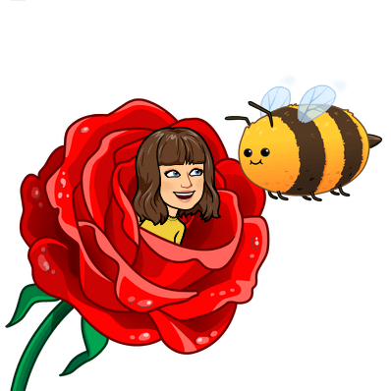
Class Text  This term, we would have been reading The Great Kapok Tree by Lynne Cherry.  Here is a video of the story being read aloud.  Can you create a story map summarising the story? | Access Bitesize Daily Lessons for a lesson each day this week on grammar. Choose the year group according to whether you are year 3 or 4. You could always select a higher or lower year group depending on difficulty required. These will be really useful practice for when we eventually return to school. | You can use Letterjoin to practise spellings.  If you need a reminder of the log in, send me an email.  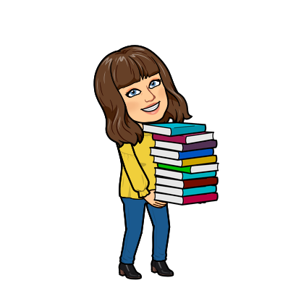 | Complete workbook activities linked to Fractions | Explore  Take a look at The Oak National Academy. Here you can find a daily schedule for your year group of lessons that have been recorded by teachers for you.

