Home Learning W/Beg: 4/5/20 (4 days)
This week the theme is VE Day. On Friday 8th May, it will be the 75th anniversary of VE (Victory in Europe) Day. This marks 75 years since the end of World War Two in Europe. On 8th May 1945, people held street parties to celebrate the end of six years of war.
I really love seeing what you have been doing at home so please keep sending me photos of your work. Hope you have a good week! mgibson@swn.dneat.org

English
VE Day Factfile  Read this article on CBBC to find out:  What is VE Day?  Write 5 facts about VE Day  What is VE day?  When did it happen?  Where did it happen?  How did people mark this day?  Where had the war not ended?  http://www.primaryhomeworkhelp.co.uk/war/end.html | Menu  Write a menu for a VE Day celebration party. Think about what foods you would like to have at your party.  Decorate your menu once you have finished. | Research your own family in WW2  Create a family tree. By doing your family tree, can you find out who in your family lived through WW2? What can you find out about them from the people who are still alive now?
Year 2 English SATs book  Learning about Poetry – Pages 42 and 43  Year 1 Comprehension Book  Read the Sign and Finish the Sentences – Pages 16 and 17 | Spellings  Practise the common exception words you did not know from last weeks big test. Pick no more than 10 to practise all week and then test on Friday.  https://spellingframe.co.uk/ a good website with free games to practise those spellings! | Reading  Remember to read for at least 10 minutes every day and continue to record reading in the reading diary.  Year 1 – Practise your phase 3 and 5 sounds every day and one page from your phonics book.

Maths
This week we are trialling the use of the White Rose Maths home learning resources. On the website (link below) there is a short video clip to explain the content. There is a worksheet to go with it. I suggest that you have the worksheet open on the computer and write the answers on a separate piece of paper to save you printing out. Please let me know how you get on with these materials.
Year 2 Maths – Using White Rose Maths Home Learning Resources Summer Term Week 2
https://whiterosemaths.com/homelearning/year-2/

Lesson 1 – Fact Families | Lesson 2 – Compare number sentences |  | Lesson 3 – Related Facts | Lesson 4 – Add and Subtract Ones |  | 2 pages from your arithmetic maths book
Year 1 Maths – Using White Rose Maths Home Learning Resources Summer Term Week 2
https://whiterosemaths.com/homelearning/year-1/

Lesson 1 – Part-whole number bonds | Lesson 2 – Fact Families |  | Lesson 3 – Add Together and Find a Part | Lesson 4 – Add more and Count On |  | 2 pages from your Addition and Subtraction booklets
Number of the Day  Try to complete 2 number of the day activities each week. Remember to challenge yourself. |  | Sumdog  The activities have been updated. |  |  | Year 2 – Tackling Tables  Don’t forget to login to complete you Tackling Tables.  I am sending out some certificates to those who have made great improvements, so keep practising!!

Year 1 - 5 Minute Mad Maths sheets can be found at http://www.snappymaths.com/addsub/addsub.htm

Topic Work
I have uploaded some additional documents onto the website. If you would like me to email a copy of anything please get in touch.
Science – Seeds  Don’t forget to look after your seeds. Complete you week 1 diary. Draw a picture of what your seed looks like. How tall is it? How many leaves has it got? (template on the website) | Flags and Bunting  Create some red, white and blue bunting to decorate your house for VE Day.  Make a union flag for you to wave on Friday.  (templates on the website) | Cooking  Make sandwiches or a cake for your tea party.  Or  You could make a wartime recipe.  WW2 Cake  Wartime Scones  Jam Tarts  (booklet on the website)
Spitfire Science  Design and make your own Spitfire. You could make it out of paper, wood, recycled materials, etc. Test out your design. How far does it glide?  Does the material used for a paper plane affect the distance it travels? Try using newspaper, card, tinfoil, etc and carry out a test. Remember, only change ONE thing to make it a fair test. | Design and Make a Medal  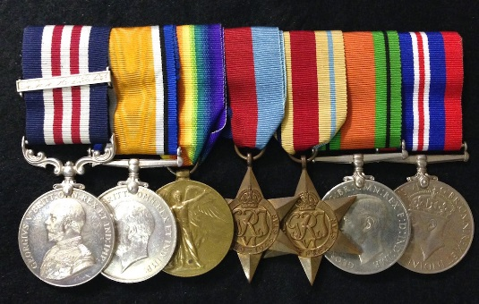  Design and make a medal. Think carefully about the colours and pictures you will use. | Music  Listen to some of the music from wartime. Do you like it? How does it make you feel? Click here to listen to some more traditional war time songs as well as the links below.  Wartime song lyrics  Run, rabbit, run!  Long way to Tipperary/ Pack up your troubles  We’ll meet again  The White Cliffs of Dover

