Home Learning W/Beg: 11/5/20
Our next topic is ‘Oceans’. This week I have chosen the book ‘The Snail and the Whale’ as a focus for our writing. I have attached a power point of the parts of the book you will need this week or a film is available on bbc iplayer.
I really love seeing what you have been doing at home so please keep sending me photos of your work. Hope you have a good week! mgibson@swn.dneat.org

English
The Snail and The Whale  Read the power point or watch https://www.bbc.co.uk/iplayer/episode/m000cslw/the-snail-and-the-whale up to 6:10. Discuss whether you think the snail should stay or go. Write a list of reasons for and against or complete the speech bubble sheet (on the website). | Adjectives  Read the power point or watch the next part of the story, up to 11:22. Choose one of the places that the snail visited (Antarctica, the mountain and beach or the ocean). Write some adjectives to describe what you can see, (eg, tall trees, a brown furry monkey). Remember an adjective is a describing word. | Postcard  Pretend you are the snail and write a postcard home from one of the places you visited (Antarctica, mountain and beach or the ocean). Try to use some of the super describing words you thought of yesterday to tell your snail family about the things you have seen.
Year 2 English SATs book  Getting Information from Instructions and Lists – Pages 44 - 45  Year 1 Comprehension Book  Little Miss Muffet and Match the Sentence – Pages 20 – 21 | Spellings  Practise the common exception words you did not know from last weeks big test. Pick no more than 10 to practise all week and then test on Friday.  https://spellingframe.co.uk/ a good website with free games to practise those spellings! | Reading  Remember to read for at least 10 minutes every day and continue to record reading in the reading diary.  Year 1 – Practise your phase 3 and 5 sounds every day and one page from your phonics book.

Maths
White Rose Maths have changed the way you access the materials On the website (link below) there is a short video clip to explain the content and it also links with BBC Bitesize Daily Lessons. I have downloaded the worksheets and sent separately to you. I suggest that you have the worksheet open on the computer and write the answers on a separate piece of paper to save you printing out. Please let me know how you get on with these materials.
Year 2 Maths – Using White Rose Maths Home Learning Resources Summer Term Week 4
https://whiterosemaths.com/homelearning/year-2/
Lesson 1 – Adding and Subtracting 10s | Lesson 2 – Add 2-digit Numbers |  | Lesson 3 – Subtract 2-digit Numbers | Lesson 4 – Bonds to 100 |  | 2 pages from your arithmetic maths book
Year 1 Maths – Using White Rose Maths Home Learning Resources Summer Term Week 4
https://whiterosemaths.com/homelearning/year-1/
Lesson 1 – Add by Making 10 | Lesson 2 – Subtract within 20 |  | Lesson 3 – Add and Subtract Worded Problems | Lesson 4 – Compare Number Sentences |  | 2 pages from your Addition and Subtraction booklets
Some people have asked for work that is not screen based so below are some ideas. Do not feel you need to all the activities, these are just suggestions, do what works for you and your child.
Fact Families  Choose 2 numbers and add them together. Now can you write 3 more related number facts. Challenge yourself to find all 8 related facts. |  | Dice Games  For the first throw, roll two dice and add the numbers together. Now roll one, and add that number on. Have a race to see who can make it to 50 or 100 first. Or start at 50/100 and subtract each time until you get to 0. |  |  | Scrabble Tiles  Use the scrabble tiles to make your name. How much is your name worth? Make the names of other people in your family. Who has the highest value?
Number of the Day  Try to complete 2 number of the day activities each week. Remember to challenge yourself. |  | Sumdog  The activities have been updated. Let me know if you have problems logging in. |  |  | Year 2 – Tackling Tables  Don’t forget to login to complete you Tackling Tables.  Well done to Emily for achieving 100!

Year 1 - 5 Minute Mad Maths sheets can be found at http://www.snappymaths.com/addsub/addsub.htm

Topic Work
I have uploaded some additional documents onto the website. If you would like me to email a copy of anything please get in touch.
Science – Seeds  Don’t forget to look after your seeds. Complete you week 1 diary. Draw a picture of what your seed looks like. How tall is it? How many leaves has it got? (template on the website)  Pip’s is the tallest so far! | Geography – Oceans  The children loved the Continents Song. Here is another song to help you learn the 5 oceans of the world.  https://www.youtube.com/watch?v=X6BE4VcYngQ | Geography – Oceans  Look at a map, globe or google maps to identify the different oceans. Draw and label a simple map to show where the oceans are. I have also attached a template for you to complete.
RE - Service  Carry out an act of service each day. Think about how it makes you feel and how it makes other people feel. Draw a picture of yourself with a thought bubble to say how it makes you feel. | Art – Moving Pictures  Can you make a moving picture of the snail and the whale?  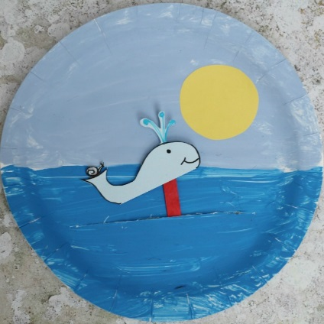 | Science – Floating and Sinking  Carry out a simple investigation to find objects that float or sink when placed in water. Record your findings in a simple table.  An interesting object is a tangerine. Test to see if it floats or sinks. Now peel it and test again. What happened? Why did that happen?

