Home Learning W/Beg: 18/5/20
Our next topic is ‘Oceans’. This week I have chosen the book ‘The Snail and the Whale’ as a focus for our writing. I have attached a power point of the parts of the book you will need this week or a film is available on bbc iplayer.
I really love seeing what you have been doing at home so please keep sending me photos of your work. Hope you have a good week! mgibson@swn.dneat.org

English
Similes  There is a line in the book that goes ‘This is the rock as black as soot’. This is a simile. A simile compares two objects using the words ‘as’ or ‘like’. I challenge you to write your own similes based on a picture from the book. | What happened next? - Plan  Think about where the snails and the whale could go on their next adventure. Plan your story by drawing a story map. (where did they go? What did they see? What happened to them? How does your story end?) Then add interesting words for each part of the plan. Can you think of at least one simile to use? | What happened next? - Story  Use your plan to write your story.  Remember  - Capital letters and full stops  - Finger spaces  - Adjectives (describing words)  - Conjunctions (and, but, so)  - A simile!
Year 2 English SATs book  Getting Information from Dialogue – Pages 46 - 47  Year 1 Comprehension Book  Spot the Odd One Out and Read the Menu – Pages 22 and 23 | Spellings  Practise the common exception words you did not know from last weeks big test. Pick no more than 10 to practise all week and then test on Friday.  https://spellingframe.co.uk/ a good website with free games to practise those spellings! | Reading  Remember to read for at least 10 minutes every day and continue to record reading in the reading diary.  Year 1 – Practise your phase 3 and 5 sounds every day and one page from your phonics book.

Maths
White Rose Maths have changed the way you access the materials On the website (link below) there is a short video clip to explain the content and it also links with BBC Bitesize Daily Lessons. I have added the worksheets to the class page on the school website. I suggest that you have the worksheet open on the computer and write the answers on a separate piece of paper to save you printing out. Please let me know how you get on with these materials.
Year 2 Maths – Using White Rose Maths Home Learning Resources Summer Term Week 5
https://whiterosemaths.com/homelearning/year-2/
Lesson 1 – Multiplication Sentences | Lesson 2 – Use Arrays |  | Lesson 3 – The 2 times-table | Lesson 4 – The 5 times-table |  | 2 pages from your arithmetic maths book
Year 1 Maths – Using White Rose Maths Home Learning Resources Summer Term Week 5
https://whiterosemaths.com/homelearning/year-1/
Lesson 1 – Compare Length and Height | Lesson 2 – Measure Length |  | Lesson 3 – Measure Length | Lesson 4 – Introduce Weight and Mass |  | 2 pages from your Addition and Subtraction booklets
Some people have asked for work that is not screen based so below are some ideas. Do not feel you need to all the activities, these are just suggestions, do what works for you and your child.
Dice  Roll 2 dice and multiply the numbers together. Write down at least 10 number sentences. |  | Ruler  Find 5 different objects to measure the height or length of around your house. Then place them in order from shortest to tallest or shortest to longest. |  |  | Maths Cooking  We use lots of measuring when we are cooking. Follow a recipe and carefully measure out the ingredients. Can’t wait to see what you make!
Number of the Day  Try to complete 2 number of the day activities each week. Remember to challenge yourself. |  | Sumdog  The activities have been updated. Let me know if you have problems logging in. |  |  | Year 2 – Tackling Tables  Don’t forget to login to complete you Tackling Tables.

Year 1 - 5 Minute Mad Maths sheets can be found at http://www.snappymaths.com/addsub/addsub.htm

Topic Work
I have uploaded some additional documents onto the website. If you would like me to email a copy of anything please get in touch.
Science – Seeds  Don’t forget to look after your seeds. Complete you week 1 diary. Draw a picture of what your seed looks like. How tall is it? How many leaves has it got? (template on the website) | Geography – Oceans  Choose one of the five oceans to research. Find out about the types of sea creatures that live there, what continents the ocean is between and any interesting facts about the ocean. Create a poster to share what you have found out. You can find a power point on the school website.  Useful website https://www.kids-world-travel-guide.com/ocean-facts-for-kids.html | Science – Penny Boat Challenge  Can you make a boat out of tin foil? Get a piece of tinfoil and make it in to a shape of a boat. Check that it floats. Now add 1p coins until your boat sinks or capsizes. Let me know how much money your boat holds.  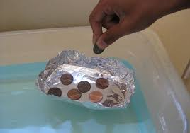
RE - Service  Think about all the people who help others every day and write a list. Think of a way we can show our thanks to them for their service. You could make a thank you card, write a letter, poster for your window or write a prayer. | Art – Under the sea  Create a diorama of an underwater scene. (A 3d picture in a box)  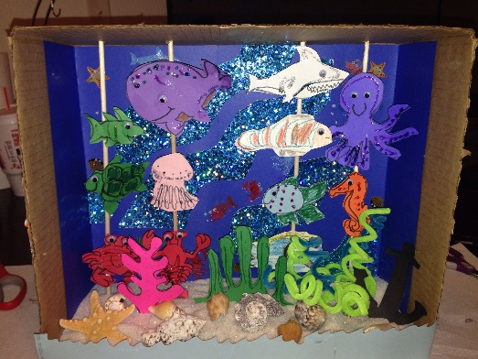 | Computing – Email  I invite you all to email me (with the help of your grown up). I would love to hear from you as I miss you all so much. Let me know what fun things you have been up to during your time at home.  mgibson@swn.dneat.org

