Home Learning W/Beg: 1/6/20
This week we are continuing our oceans theme by looking at all the different sea creatures. I really love seeing what you have been doing at home so please keep sending me photos of your work. Hope you have a good week! mgibson@swn.dneat.org

English
Half Term News  Write a letter to tell me what you have been up to over half term. Include a photo or draw a picture for the website. | Comprehension  Read the ‘Sea Creatures’ fact files and discuss any words you do not know. Look at the question sheet and answer the questions about the sea creatures. Remember all the answers can be found in the text.  Resource sent by email or can be found on the website. | Sea Creatures Book  Make a book about your favourite sea creatures. Draw a picture and write a sentence about each creature. Choose at least three different animals.
Year 2 English SATs book  Question Marks and Exclamation Marks – Pages 92 and 93  Year 1 Comprehension Book  Reasons and Party Time – Pages 24 and 25 | Spellings  Practise the common exception words you did not know from last weeks big test. Pick no more than 10 to practise all week and then test on Friday.  https://spellingframe.co.uk/ a good website with free games to practise those spellings! | Reading  Remember to read for at least 10 minutes every day and continue to record reading in the reading diary.  Year 1 – Practise your phase 3 and 5 sounds every day and one page from your phonics book.

Maths
White Rose Maths have changed the way you access the materials On the website (link below) there is a short video clip to explain the content and it also links with BBC Bitesize Daily Lessons. I have added the worksheets to the class page on the school website. I suggest that you have the worksheet open on the computer and write the answers on a separate piece of paper to save you printing out. Please let me know how you get on with these materials.
Year 2 Maths – Using White Rose Maths Home Learning Resources Summer Term Week 6
https://whiterosemaths.com/homelearning/year-2/
Lesson 1 – The Ten Times-table | Lesson 2 – Make equal groups (sharing) |  | Lesson 3 – Make equal groups (grouping) | Lesson 4 – Odd and Even Numbers |  | 2 pages from your arithmetic maths book  Or Crack the Code
Year 1 Maths – Using White Rose Maths Home Learning Resources Summer Term Week 6
https://whiterosemaths.com/homelearning/year-1/
Lesson 1 – Measure Mass | Lesson 2 – Compare Mass |  | Lesson 3 – Capacity and Volume | Lesson 4 – Measure Capacity |  | 2 pages from your Addition and Subtraction booklets  Or Crack the Code
Some people have asked for work that is not screen based so below are some ideas. Do not feel you need to all the activities, these are just suggestions, do what works for you and your child.
Times Tables Posters  Make some posters to help you learn your 2x, 3x, 5x and 10x tables.  Year 2 – make a 4x table poster to help you get ready for year 3. |  | Kitchen Maths  Look at the weight measurements on packets, tins and bags that you can find in the kitchen cupboards. Place the objects in order from lightest to heaviest. |  |  | Maths Cooking  We use lots of measuring when we are cooking. Follow a recipe and carefully measure out the ingredients. Can’t wait to see what you make!
Number of the Day  Try to complete 2 number of the day activities each week. Remember to challenge yourself. |  | Sumdog  The activities have been updated. Let me know if you have problems logging in. |  |  | Year 2 – Tackling Tables  Don’t forget to login to complete you Tackling Tables.

Year 1 - 5 Minute Mad Maths sheets can be found at http://www.snappymaths.com/addsub/addsub.htm

Topic Work
I have uploaded some additional documents onto the website. If you would like me to email a copy of anything please get in touch.
Science – Seeds  Don’t forget to look after your seeds. Complete you weekly diary. Draw a picture of what your seed looks like. How tall is it? How many leaves has it got? (template on the website) |  | Science – Food Chains  The ocean contains many different creatures and they all rely on each other for food. Watch the BBC Bitesize clip or the powerpoint and find out about food chains. Create a simple 3 link food chain starting with a plant.
RE – Truthfulness  This term our Christian value is truthfulness. Discuss what it means with your family. Think about why it is important to be truthful. | Art  Create a model of a sea creature.  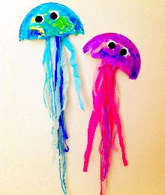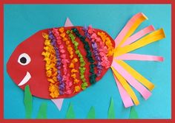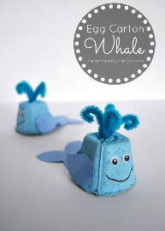 |  | Computing – Programing  Human Robot  See additional sheet

