Winston Churchill

Sir Winston Leonard Spencer-Churchill was a British politician, army officer and writer. He was born 30th November 1874 and died 24th January 1965. He was prime minister of the United Kingdom from 1940-1945 and again from October 1951 until April 1955.

Winston Churchill was famous for his inspiring speeches and his refusal to give in even when things were going badly. Many people consider him to be the greatest Briton of all time and almost certainly the most famous British Prime minister.
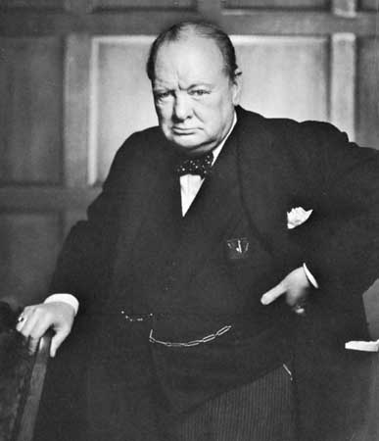

Code
Kaden -kilo alfa delta echo November.

Kaden Underwood

