Can I predict?
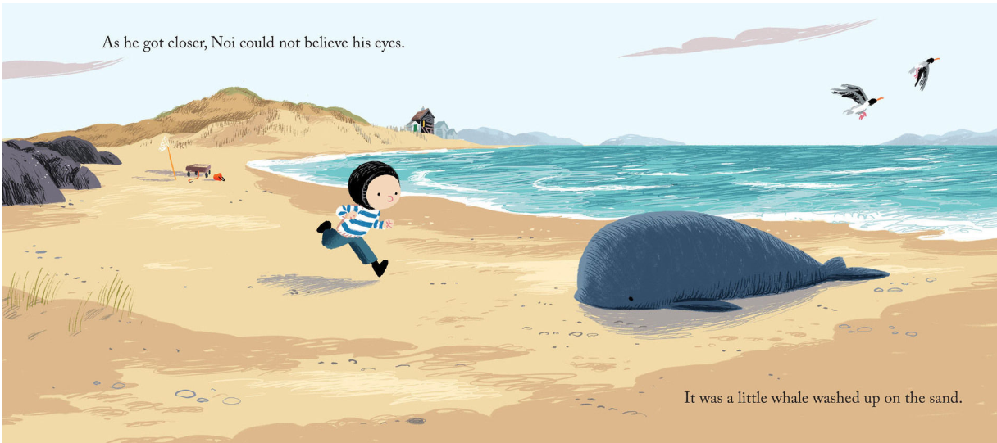
What do you think will happen next? Provide as much detail as you can.

. | Write a statement.
! | Write a sentence to show surprise
? | Write a question
Can I write sentences using correct punctuation?

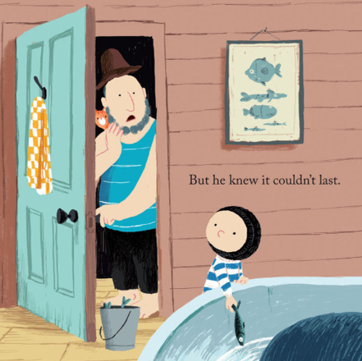

Can I sort nouns, verbs and adjectives?
noun | The word given to a person, place or thing
verb | A doing or action word
adjective | A describing word
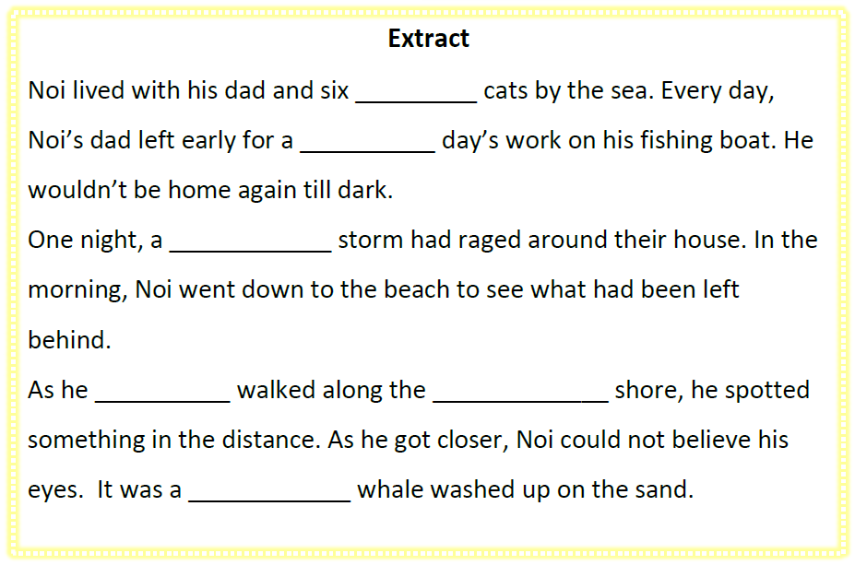
Nouns | Verbs | Adjectives  Read the sentences and choose an adjective to use.
1. | 1.
2. | 2.
3. | 3.
4. | 4.
5. | 5.

