Can I write about the setting?
Look at the picture carefully. Write sentences to describe the setting of this story.
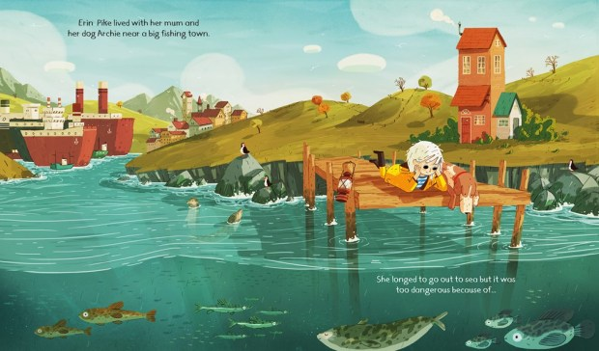

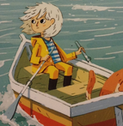
Can I describe a character? Use interesting adjectives to describe Erin Pike.

