Reading | Writing | Spellings | Maths  Theme for the week: Fractions | Curriculum
Read Online  Get your child to read a book on Oxford Owl, there are books for all ages and abilities. Sign in details below;  Username: Sandringham34  Password: Sandringham  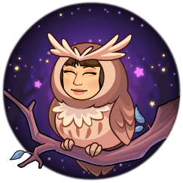 | Pobble Challenge  Complete a challenge from Pobble ‘Lost’ (03/06). If you click on the PDF below the picture, it will give you a story starter and some other ideas. If you don’t fancy writing a story, you could always try the ‘Perfect Picture’ challenge. | Common Exception Words  Continue you to work on learning to read and spell the Year 3 and 4 Common Exception Words. By the end of LKS2 you should be able to use these words confidently. | Tackling Tables  Use your log on to access Tackling Tables and practise in Learn, Play or Test mode | Be Active  Complete a daily workout following PE with Joe Wicks or have a go at some yoga. Check out Cosmic Kids Yoga
Explore Vocabulary  Explore new vocabulary you find when reading.  - Write down new words.  - Look them up in the dictionary  - Find a synonym or antonyms for your new word | Quick Fire Write!  Have a go at one of the Quick Fire Write challenges. These are writing prompts that you should respond to in 200-400 words and you can submit your final outcomes online. | Choose 10 Common Exception Words to focus on for the week.  Write a synonym, antonyms, the meaning and an example of how to use the word in a sentence. Can the word be modified? | Access Bitesize Daily Lessons. The theme this week is Fractions (again!) | Get Creative  Blue Peter have launched 6 Badges of Summer. Each badge is based on a different skill/theme so there is something for everyone. Being awarded a Blue Peter badge would a fabulous memento from lockdown and it gains you free access to lots of days out around the country which is a real bonus!
Reading Lesson  Access Bitesize Daily Lessons for a lesson on Kensuke’s Kingdom by Michael Morpurgo. This is a book that I would really recommend. Have you got any book recommendations for me? | Author Masterclass  If you are an aspiring author, take an Author Masterclass. It may take a few moments to sign up but the content is free and inspiring. The 10 minute challenges are great too!  Anna Fargher wrote The Umberella Mouse which is a fab book (we have read it at home) set during the war. I think that some of you would love it!! | Can you use 10 Common Exception Words in your Pobble Challenge task? | Emoji Maths  This is a fun way for the children to practice addition and subtraction. We did it in school last week and the children really enjoyed it!  Find the document attached to my email and on the website. | Investigate  Sumdog – This is an online learning platform where the children can practice Maths and English skills whilst playing interactive games with their class mates. I have sent log on details out individually.
Class Text  This term, we would have been reading The Great Kapok Tree by Lynne Cherry.  Here is a video of the story being read aloud.  Have a look at the reading activities document I have attached to my weekly email and posted on the website. Choose one to complete in relation to The Great Kapok Tree | Access Bitesize Daily Lessons for a lesson each day this week on grammar. Choose the year group according to whether you are year 3 or 4. You could always select a higher or lower year group depending on difficulty required. These will be really useful practice for when we eventually return to school. | You can use Letterjoin to practise spellings.  If you need a reminder of the log in, send me an email.  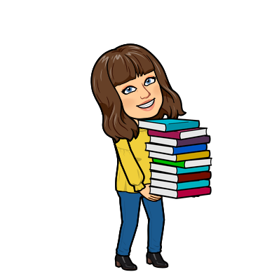 | Complete workbook activities linked to Fractions | Explore  Take a look at Classroom Secrets Kids. Here you can find games and tutorials that support the learning available through BBC Bitesize.

