Reading | Writing | Spellings | Maths  Theme for the week: Y3 – Fractions Y4 - Decimals | Curriculum
Read Online  Get your child to read a book on Oxford Owl, there are books for all ages and abilities. Sign in details below;  Username: Sandringham34  Password: Sandringham | Pobble Challenge  Complete a challenge from Pobble ‘Waiting’ (20/06). If you click on the PDF below the picture, it will give you a story starter and some other ideas. Have a go at ‘Question Time’ followed by the ‘Perfect Picture’ challenge. | Common Exception Words  Continue you to work on learning to read and spell the Year 3 and 4 Common Exception Words. By the end of LKS2 you should be able to use these words confidently.  If you are year 4 and feel like you have mastered these words. Have a look at the Year 5 and 6 Common Exception Words | Tackling Tables  Use your log on to access Tackling Tables and practise in Learn, Play or Test mode.  I was able to give out a certificate this week which was super exciting ! | Be Active  Complete a daily workout following PE with Joe Wicks or have a go at some yoga. Check out Cosmic Kids Yoga  You could also take part in the Norfolk Virtual School Games Rainbow Run
Comprehension  I know that some of you have completed your workbooks so I have attached a comprehension to the weekly email so that you can keep practicing.  This weeks is about World Ocean’s Day which was last Monday. | Write a Poem  Can you write a poem inspired by the sounds of a tropical rainforest. | Choose 10 Common Exception Words to focus on for the week.  Write a synonym, antonyms, the meaning and an example of how to use the word in a sentence. Can the word be modified? | Access Bitesize Daily Lessons. The theme this week is (more) Fractions for Year 3 and Decimals for Year 4 | Get Creative  Design a duck for the BBC Children in Need Duck race. Details of how to enter the competition can be found here.
Reading Lesson  Access Bitesize Daily Lessons for a lesson on Slime by David Walliams. We have been reading this book at home and it is very funny. Also it uses lots of sound words which would be interesting to look at for the other Bitesize lessons on poetry this week. | Author Masterclass  If you are an aspiring author, take an Author Masterclass. It may take a few moments to sign up but the content is free and inspiring. The 10 minute challenges are great too! Katherine Rundell wrote The Explorer which is set in the rainforest. There are some freat videos including why she decided to set a story in The Amazon Rainforest. Are any of you up for the challenge of reading this book? | Can you use 10 Common Exception Words in your Pobble Challenge task or poem? | Football Themed Fractions  This is a fun way for the children to practice shading fractions.  Find the document attached to my email and on the website. | Investigate  This half term our Christian Value is Truthfulness.  Discuss the importance of telling the truth.  Last week’s Art and Design BBC Bitesize Lesson on Sculpture was also interesting.
Class Text  This term, we would have been reading The Great Kapok Tree by Lynne Cherry.  Here is a video of the story being read aloud.  Have a look at the reading activities document I have attached to my weekly email and posted on the website. Choose one to complete in relation to The Great Kapok Tree  *I have left this week as there are lots of activities that you can choose from in relation to the same text. | Access Bitesize Daily Lessons for a lesson each day this week on poetry. Choose the year group according to whether you are year 3 or 4. You could always select a higher or lower year group depending on difficulty required. These will be really useful practice for when we eventually return to school. | You can use Letterjoin to practise spellings.  If you need a reminder of the log in, send me an email.  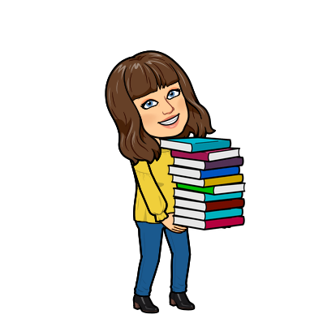 | Complete workbook activities linked to Fractions or Decimals | Explore  Take a look at Classroom Secrets Kids. Here you can find games and tutorials that support the learning available through BBC Bitesize.

