Home Learning W/Beg: 8/6/20
This week our work is based on the book ‘The Storm Whale’. I have attached a Powerpoint or you can listen to it here https://www.youtube.com/watch?v=zT9LnMQiplc&t=11s Please do not read the whole book until you have completed first two activities. I really love seeing what you have been doing at home so please keep sending me photos of your work. Hope you have a good week! mgibson@swn.dneat.org

English
Prediction  Read the first few pages of ‘The Storm Whale’ or watch up to 1:06. Talk about what happens next. What will Noi do? What happens to the whale? Does Dad come back? Write your prediction, include as much detail as you can. | Speech Bubbles  Continue reading the story (stopping at 2:05). Think about what Dad would say when he found the whale. What would Noi say back to Dad? Write speech bubbles for each character. Try to write a statement, a question and an exclamation sentence.  Statement https://www.bbc.co.uk/bitesize/articles/z97r2nb  Questions  https://www.bbc.co.uk/bitesize/topics/zrqqtfr/articles/z2xdng8  Exclamation  https://www.bbc.co.uk/bitesize/topics/zrqqtfr/articles/zqbjy4j | Nouns, Verbs and Adjectives  Nouns https://www.bbc.co.uk/bitesize/topics/zrqqtfr/articles/zpd8ng8  Verbs https://www.bbc.co.uk/bitesize/topics/zrqqtfr/articles/zpxhdxs  Adjectives https://www.bbc.co.uk/bitesize/topics/zrqqtfr/articles/zy2r6yc  Read the section of text and identify the nouns and verbs. Try adding some adjectives to make the sentences more interesting.
Year 2 English SATs book  Commas – Pages 94 and 95  Year 1 Comprehension Book  At the Airport – Pages 26 and 27 | Spellings  Practise the common exception words you did not know from last weeks big test. Pick no more than 10 to practise all week and then test on Friday.  https://spellingframe.co.uk/ a good website with free games to practise those spellings! | Reading  Remember to read for at least 10 minutes every day and continue to record reading in the reading diary.  Year 1 – Practise your phase 3 and 5 sounds every day and one page from your phonics book.

Maths
White Rose Maths have changed the way you access the materials On the website (link below) there is a short video clip to explain the content and it also links with BBC Bitesize Daily Lessons. I have added the worksheets to the class page on the school website. I suggest that you have the worksheet open on the computer and write the answers on a separate piece of paper to save you printing out.
Year 2 Maths – Using White Rose Maths Home Learning Resources Summer Term Week 7
https://whiterosemaths.com/homelearning/year-2/
Lesson 1 – Unit fractions | Lesson 2 – Non-unit fractions |  | Lesson 3 – Find a half | Lesson 4 – Find a quarter |  | 2 pages from your arithmetic maths book
Year 1 Maths – Using White Rose Maths Home Learning Resources Summer Term Week 7
https://whiterosemaths.com/homelearning/year-1/
Lesson 1 – Count in 2s | Lesson 2 – Count in 5s |  | Lesson 3 – Count in 10s | Lesson 4 – Add equal groups |  | 2 pages from your Addition and Subtraction booklets
Some people have asked for work that is not screen based so below are some ideas. Do not feel you need to all the activities, these are just suggestions, do what works for you and your child.
Counting Groups  Go outside and collect objects to create a counting picture. Put the objects in to equal groups of 2 or 5 or 10 and count them. Challenge – can you write a multiplication to match the picture?  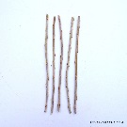  5 10 15 20  5 x 4 = 20 |  | Food Maths  Can you find some foods to cut in half and quarters? (eg. sandwich, toast, banana) Remember each part needs to be equal. Or if you have a packet of sweets (smarties are good!) can you find out half and quarter of the packet? Challenge – what would ¾ be? Or a 1/3? |  |  | Telling the Time  Make or draw a clock face and cut out two strips for the hands. Place the hands on the clock to show different times.  Year 1 – o’clock and half past  Year 2 – o’clock, half past, quarter to and quarter past  Challenge – all minutes past
Number of the Day  Try to complete 2 number of the day activities each week. |  | Sumdog  The activities have been updated. |  |  | Year 2 – Tackling Tables  Don’t forget to login to complete you Tackling Tables.

Year 1 - 5 Minute Mad Maths sheets can be found at http://www.snappymaths.com/addsub/addsub.htm

Topic Work
I have uploaded some additional documents onto the website. If you would like me to email a copy of anything please get in touch.
Science – Seeds  Don’t forget to look after your seeds. Complete you weekly diary. Draw a picture of what your seed looks like. How tall is it? How many leaves has it got? (template on the website) | Science – World Ocean Day  On Monday it is World Ocean Day. There is a day of activities planned on https://worldoceanday.school/ | Science - Plastic Pollution  Watch ‘Someone Swallowed Stanley’ https://www.youtube.com/watch?v=vGgXzPidGaQ  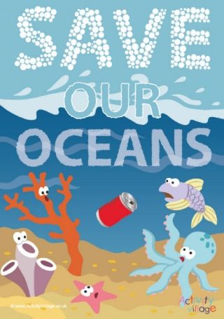  Create a poster to tell people what they should do with their rubbish and how they can look after the creatures in the sea.  Just for fun, you could make a kite out of a plastic bag!
Christian Value – Truthfulness  Read the story about Raisa and Jenny with a grown up and discuss the importance of telling the truth.  See additional sheet | Art  Make a model of a whale. Send me a photograph so that I can add it to our display in class.  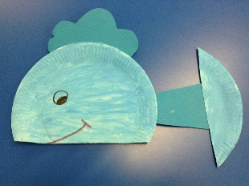 | Computing – Programing  Creating Patterns  See additional sheet

