Home Learning W/Beg: 15/6/20
This week our work is based on the book ‘The Storm Whale’. I have attached a Powerpoint or you can listen to it here https://www.youtube.com/watch?v=zT9LnMQiplc&t=11s Please do not read the whole book until you have completed first two activities. I really love seeing what you have been doing at home so please keep sending me photos of your work. Hope you have a good week! mgibson@swn.dneat.org

English
Comprehension  Read the book or watch the film. Now answer the comprehension questions about ‘The Storm Whale’.  See additional sheet page 1 | Story – Choose one  Retell the story in your own words.  OR  Write your own version changing the animal, eg The Storm Dolphin | Compare Stories  Watch ‘The Storm Whale in Winter’. https://www.youtube.com/watch?v=PPtet0D2zHc Afterwards compare the two stories, looking for similarities and differences. Think about the characters, events and main themes of each story.  Additional sheet if required
Year 2 English SATs book  Present Tense – Page 96 and 97  Year 1 Comprehension Book  My Favourite Book – Page 28  Draw a picture of your favourite book to share with me. | Spellings  Practise the common exception words you did not know from last weeks big test. Pick no more than 10 to practise all week and then test on Friday.  https://spellingframe.co.uk/ a good website with free games to practise those spellings! | Reading  Remember to read for at least 10 minutes every day and continue to record reading in the reading diary.  Year 1 – Practise your phase 3 and 5 sounds every day and one page from your phonics book.

Maths
White Rose Maths have changed the way you access the materials On the website (link below) there is a short video clip to explain the content and it also links with BBC Bitesize Daily Lessons. I have added the worksheets to the class page on the school website. I suggest that you have the worksheet open on the computer and write the answers on a separate piece of paper to save you printing out.
Year 2 Maths – Using White Rose Maths Home Learning Resources Summer Term Week 8
https://whiterosemaths.com/homelearning/year-2/
Lesson 1 – Properties of 2D shapes | Lesson 2 – Properties of 3D shapes |  | Lesson 3 – Sorting Shapes | Lesson 4 – Shape Patterns |  | 2 pages from your arithmetic maths book
Year 1 Maths – Using White Rose Maths Home Learning Resources Summer Term Week 8 ALTERNATIVE PLAN
https://whiterosemaths.com/homelearning/year-1/
Lesson 1 – 1 more and 1 less | Lesson 2 – Compare objects within 50 |  | Lesson 3 – Compare numbers within 50 | Lesson 4 – Order numbers within 50 |  | 2 pages from your Addition and Subtraction booklets
Some people have asked for work that is not screen based so below are some ideas. Do not feel you need to all the activities, these are just suggestions, do what works for you and your child.
Shape Hunt  Look for 2D and 3D shapes around your house and make a list of what you find. What shape did you find the most of? The least of? |  | Patterns  Can you create a repeating pattern? You could draw one or make one using objects from around the house. Challenge yourself to make harder patterns each time. |  |  | Number Hunt  On a walk collect numbers that you see on road signs, number plates and door numbers. Once back at home can you put all the numbers in order.
Number of the Day  Try to complete 2 number of the day activities each week. |  | Sumdog  The activities have been updated. |  |  | Year 2 – Tackling Tables  Don’t forget to login to complete you Tackling Tables.

Year 1 - 5 Minute Mad Maths sheets can be found at http://www.snappymaths.com/addsub/addsub.htm

Topic Work
I have uploaded some additional documents onto the website. If you would like me to email a copy of anything please get in touch.
Science – Seeds  Don’t forget to look after your seeds. Complete you weekly diary. Draw a picture of what your seed looks like. How tall is it? How many leaves has it got? (template on the website) | Science – Scientists  Find out what a marine biologist does.  Rachel Carson was a famous marine biologist, can you find out what she discovered? Create a simple fact file about what you have found out.  Powerpoint on website | PE – Rainbow Run  Last week in school we took part in the Norfolk Schools Rainbow Run and now it is your turn! Dress up in your brightest, most colourful clothes and run. Send in a photo so we can add it to our display in school.
Christian Value – Truthfulness  Read the story about ‘The Boy who Cried Wolf’. What does this story teach us? Why is it important to tell the truth? What happens if we are not always truthful?  Powerpoint on website | Art - Silhouette  At the end of the book there is a silhouette of a whale swimming in the sea. Can you create a silhouette painting? What animal will you choose?  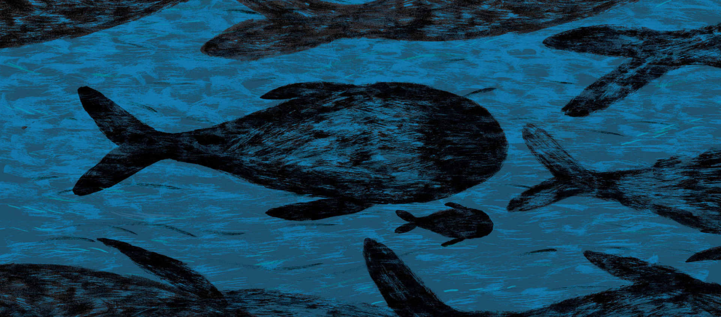 | Computing – Programming  https://lightbot.com/hour-of-code.html  Can you program the robot to move and light up?  OR  Download the Bee-bot App for Apple or Android

