Diary of a Seagull

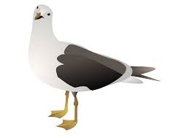

Saturday

|  |
| --- |
|  |
|  |
|  |
|  |
|  |
|  |

Friday

|  |
| --- |
|  |
|  |
|  |
|  |
|  |
|  |

Thursday

|  |
| --- |
|  |
|  |
|  |
|  |
|  |
|  |

Tuesday

|  |
| --- |
|  |
|  |
|  |
|  |
|  |
|  |

Wednesday

|  |
| --- |
|  |
|  |
|  |
|  |
|  |
|  |

Monday

|  |
| --- |
|  |
|  |
|  |
|  |
|  |
|  |