The Pirates Next Door
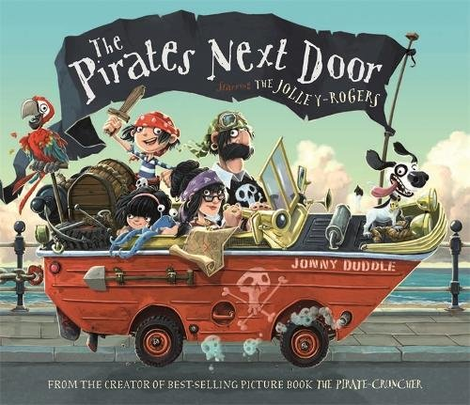
How would you feel living next door to pirates?

What would you do if you lived next door to pirates?
Dear Councilor,
I am writing this letter to complain about the pirates that have moved into my neighbourhood.
First,
Secondly,
Finally,
Yours sincerely,

___________________

