Thank You and a Reflection of the Year
As we reach the end of the school year I would like to say a very big thank you to you all for your support over what has been an extraordinary year! Last September we could never have predicted we would be faced with working through a global pandemic and the challenges of lockdown, social distancing and remote learning. You have all been amazing with how you have coped with the changes and continued learning in such strange circumstances.
This week I would like you to reflect on your home school journey. What have you enjoyed? What memories will you treasure? How did you stay in contact with your friends? Did you learn a new skill? I have attached a memories sheet for you to complete if you wish or you could write about your experiences and create a book about your time and include photographs and pictures.

Summer Holiday Ideas
Summer Reading  Join the Norfolk Libraries Summer Reading Challenge. This year the theme is ‘Silly Squad’. More information here  www.summerreadingchallenge.org.uk  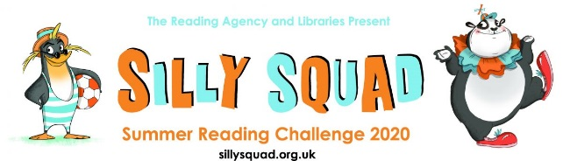 | Blue Peter Badges  Apply for a Blue Peter Badge.  More details here https://www.bbc.co.uk/cbbc/joinin/six-badges-of-summer
Summer Diary  Keep a diary of your summer holiday. It would be lovely to share it when we return to school in September. | 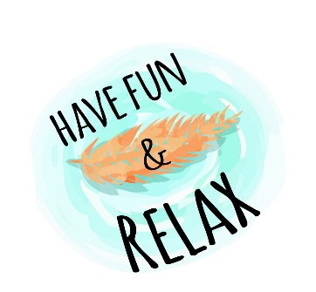

Hope you all have a lovely summer, stay safe and see you in September!
Mrs Gibson

