Year 1 and 2 Autumn 1

Our topic is “Superheroes”

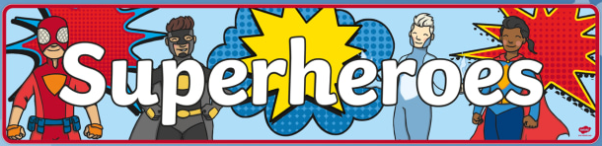

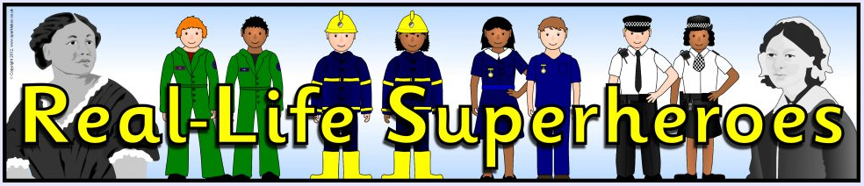

**Computing**

We will be learning how to keep ourselves safe online.

**Maths**

In maths, we will be covering work on numbers and place value, and on the four number operations, addition, subtraction, multiplication and division.

**PE**

We will be working on our long distance running skills and improving our jumping technique.

**Art and Design**

We will be painting portraits of ourselves. We will also be learning how to mix paint to create new colours.

In Design Technology we will be learning about healthy foods and creating our own healthy lunch.

**RE**

We will be exploring the big question ‘How do Christians belong to their faith family?’.

**History**

We will be finding out about some superhero nurses; Florence Nightingale, Mary Seacole and Edith Cavill.

**Science**

In science, we will be learning all about our bodies and our five senses. We will also find out how we can stay healthy.

**English**

In English, we will be enjoying the story ‘Supertato’. We will be writing our own stories and creating a descriptive poster for the evil pea. We will also learn about nouns and adjectives.