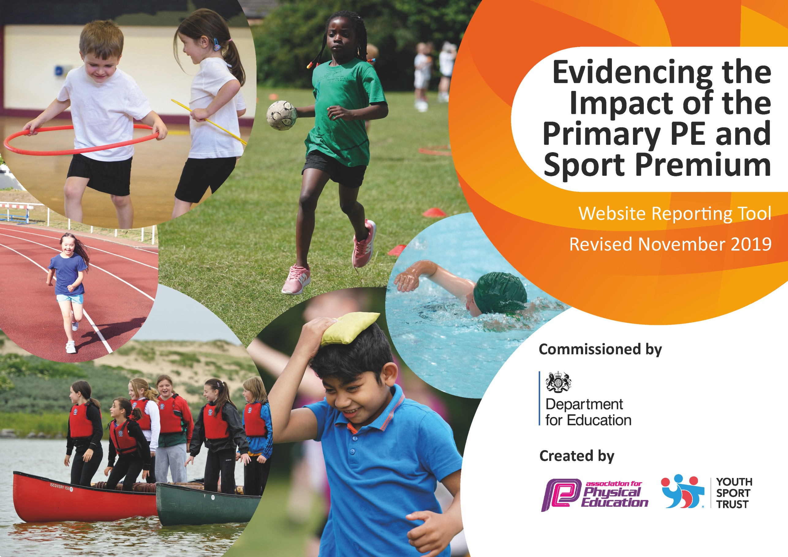
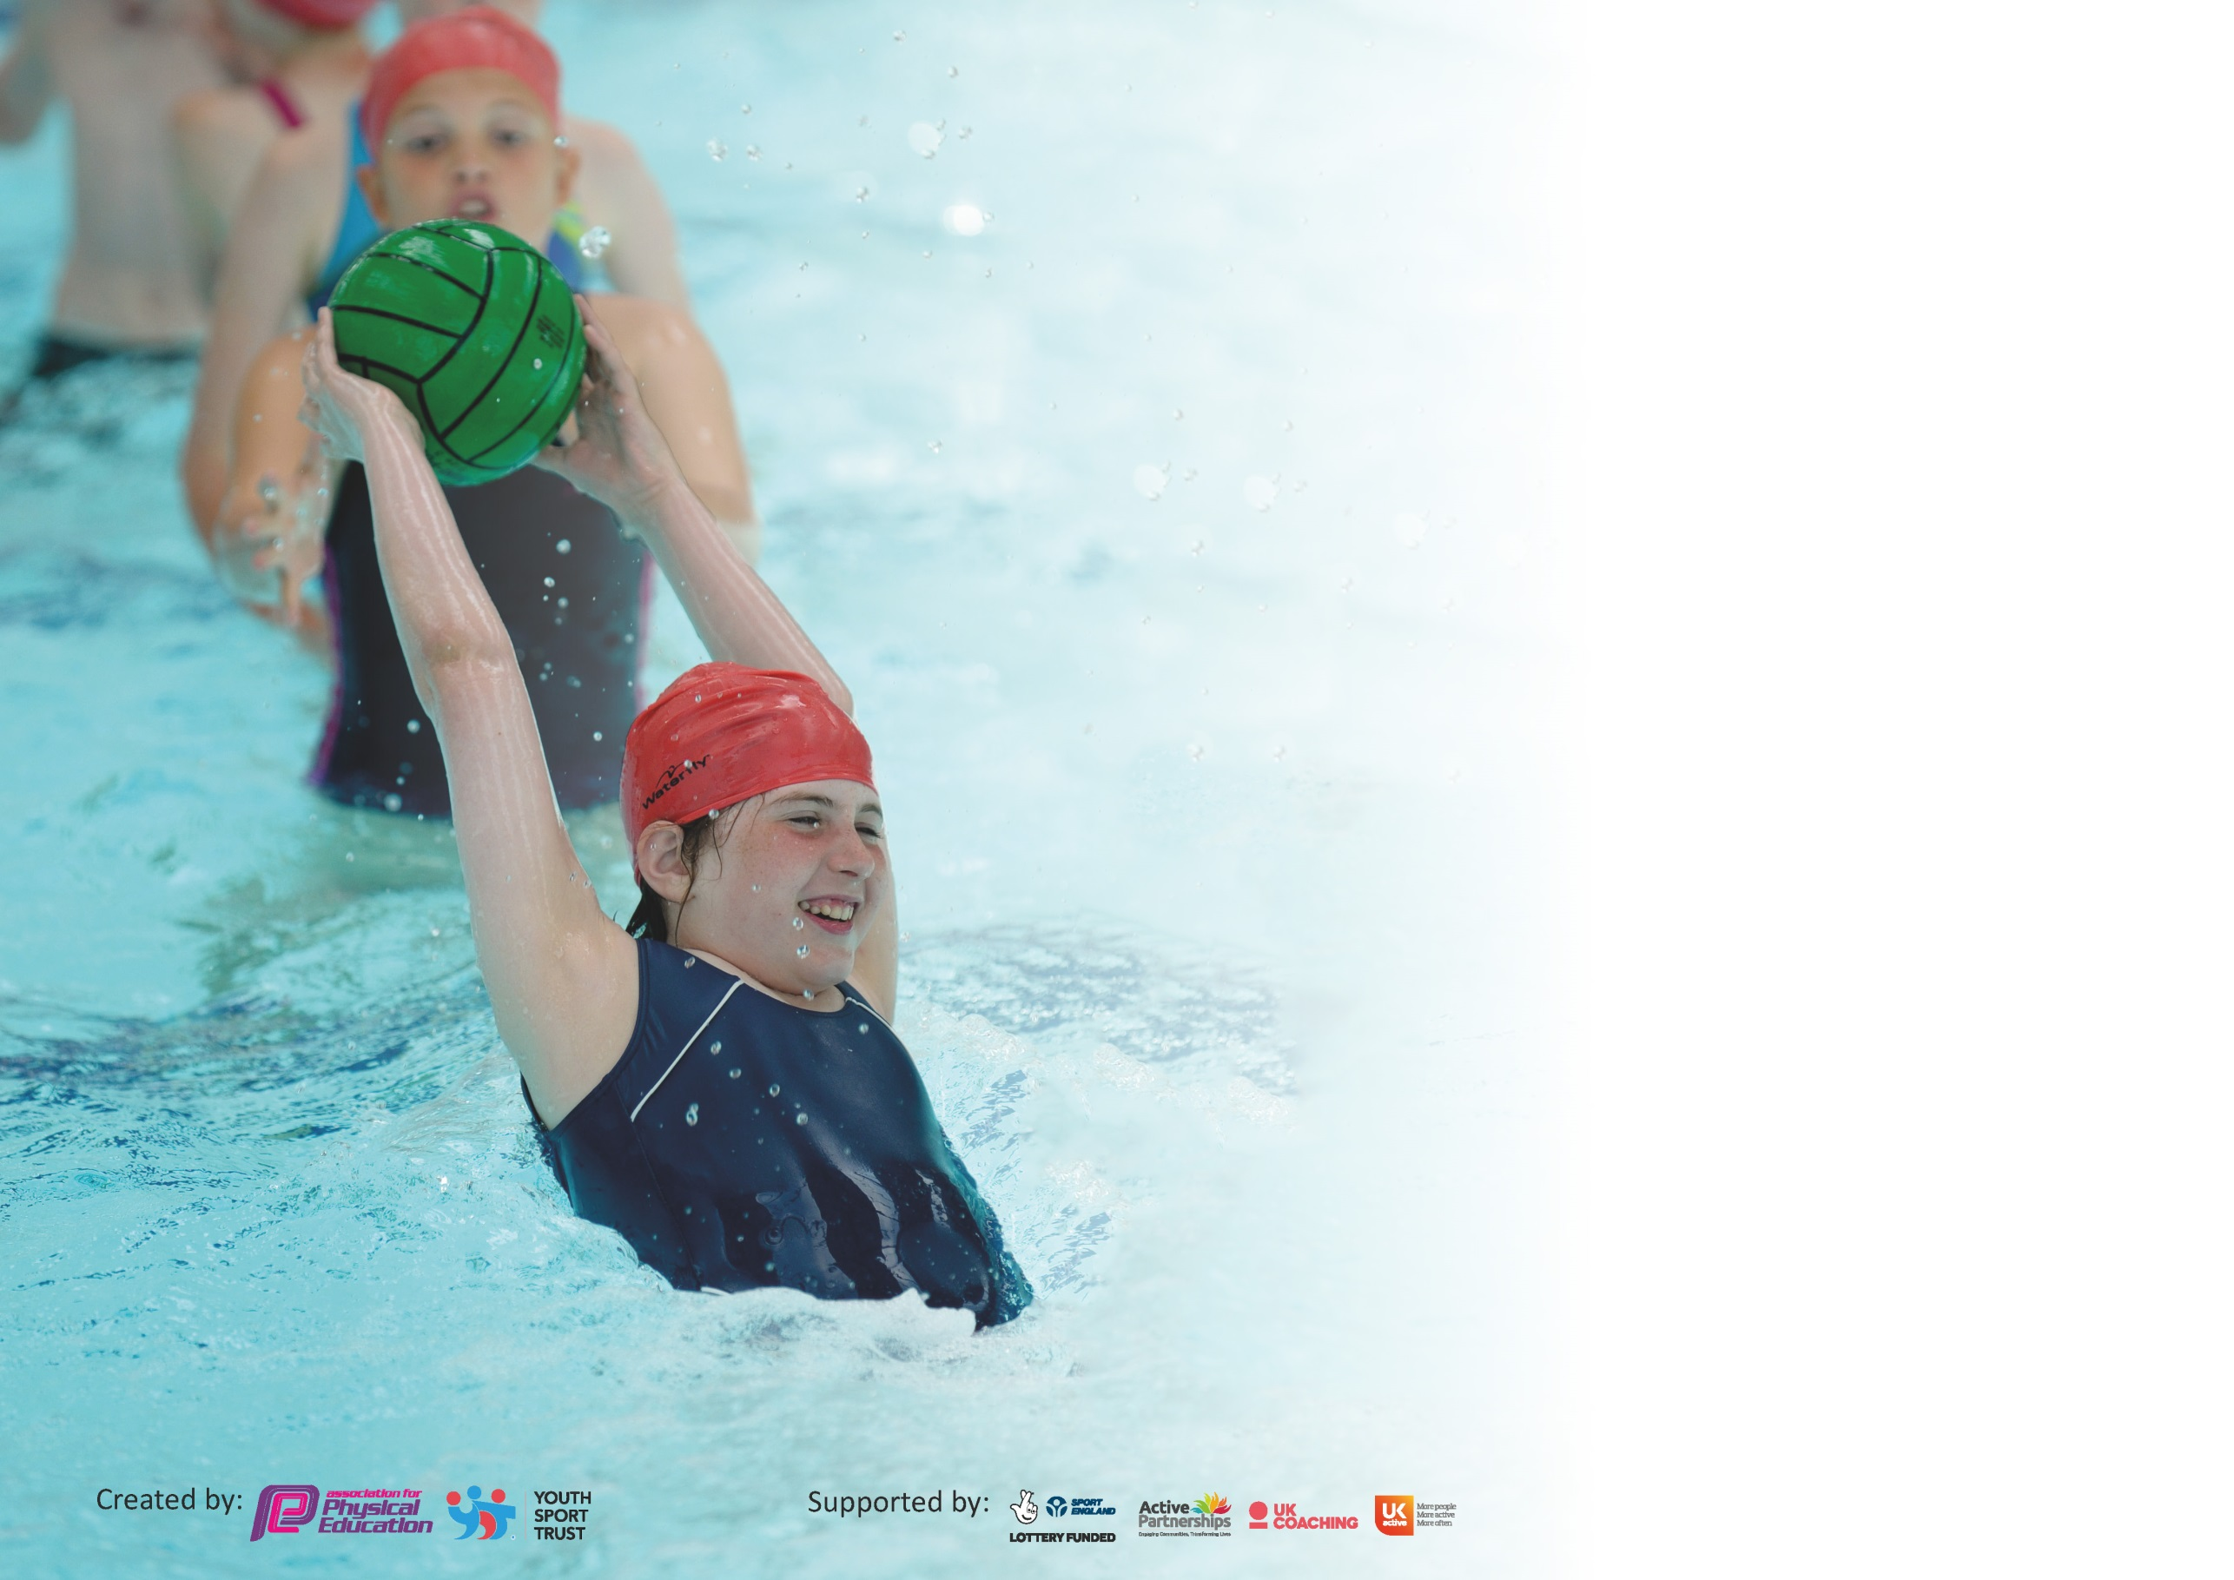

It is important that your grant is used effectively and based on school need. The Education Inspection Framework (Ofsted 2019 p64) makes clear there will be a focus on ‘whether leaders and those responsible for governors all understand their respective roles and perform these in a way that enhances the effectiveness of the school’.

Under the Quality of Education criteria (p41) inspectors consider the extent to which schools can articulate their curriculum (INTENT), construct their curriculum (IMPLEMENTATION) and demonstrate the outcomes which result (IMPACT).

To assist schools with common transferable language this template has been developed to utilise the same three headings which should make your plans easily transferable between working documents.

Schools must use the funding to make additional and sustainable improvements to the quality of Physical Education, School Sport and Physical Activity (PESSPA) they offer. This means that you should
use the Primary PE and Sport Premium to:

- Develop or add to the PESSPA activities that your school already offer
- Build capacity and capability within the school to ensure that improvements made now will benefit pupils joining the school in future years

Please visit gov.uk for the revised DfE guidance including the 5 key indicators across which schools should demonstrate an improvement. This document will help you to review your provision and to report your spend. DfE encourages schools to use this template as an effective way of meeting the reporting requirements of the Primary PE and Sport Premium.

We recommend you start by reflecting on the impact of current provision and reviewing the previous spend.

Schools are required to publish details of how they spend this funding as well as on the impact it has on pupils’ PE and sport participation and attainment by the end of the summer term or by 31st July 2020 at the latest.

We recommend regularly updating the table and publishing it on your website throughout the year. This evidences your ongoing self-evaluation of how you are using the funding to secure maximum, sustainable impact. Final copy must be posted on your website by the end of the academic year and no later than the 31st July 2020. To see an example of how to complete the table please click HERE.

Support for review and reflection - considering the 5 key indicators from DfE, what development needs are a priority for your setting and your pupils now and why? Use the space below to reflect on previous spend and key achievements and areas for development.

Key achievements to date until July 2020: | Areas for further improvement and baseline evidence of need:
5 key indicators  - The engagement of all pupils in regular physical activity - the Chief Medical Officer guidelines recommend that all children and young people aged 5 to 18 engage in at least 60 minutes of physical activity a day, of which 30 minutes should be in school –  Achievements include : daily mile, at least 2 hours of curriculum PE lessons per week, swimming lessons regularly across all year groups, encouragement of PE outside of school by celebrated achievement in sharing assembly.  - The profile of PE and sport is raised across the school as a tool for whole-school improvement  Achievements include : attainment of the Gold sports mark award.  - Increased confidence, knowledge and skills of all staff in teaching PE and sport  Use of Sports funding to provide additional coaching for teachers eg Specialist dance teacher to demonstrate lessons.  - Broader experience of a range of sports and activities offered to all pupils  Achievements : Additional broad experience eg: sailing lessons in year 6, forest schools for all years, cycling proficiency, bikeabiity,  - Increased participation in competitive sport  Achievements :- Cross country competition – pupils achieving to final round WEST Norfolk competitions, Netball team does exceedingly well in County High 5s netball. | 2020-2021 – difficulty of maintaining under current restrictions – finding time in curriculum  Completing Sportsmark across federation – allowing PE Leader to lead across federation.  Continue with dance coaching in both schools, weakest areas of confidence in teachers.  Continue extra provision eg Sailing, explore other sports.  Difficult under current restrictions – currently competing virtually.

Meeting national curriculum requirements for swimming and water safety.
What percentage of your current Year 6 cohort swim competently, confidently and proficiently over a distance of at least 25 metres?  N.B. Even though your pupils may swim in another year please report on their attainment on leaving  primary school at the end of the summer term 2020. | 100% in year 6
What percentage of your current Year 6 cohort use a range of strokes effectively [for example, front crawl, backstroke and breaststroke]? | 100% in year 6
What percentage of your current Year 6 cohort perform safe self-rescue in different water-based situations? | 100% in year 6%
Schools can choose to use the Primary PE and Sport Premium to provide additional provision for swimming but this must be for activity over and above the national curriculum requirements. Have you used it in this way? | Yes

Action Plan and Budget Tracking
Capture your intended annual spend against the 5 key indicators. Clarify the success criteria and evidence of impact that you intend to measure to evaluate for pupils today and for the future.

Academic Year: 2020-2021 | Total fund allocated: £33,360 across Federation | Date Updated: October 2020
Key indicator 1: The engagement of all pupils in regular physical activity – Chief Medical Officer guidelines recommend that primary school pupils undertake at least 30 minutes of physical activity a day in school |  |  |  | Percentage of total allocation:
 |  |  |  | 36%
Intent | Implementation |  | Impact
Your school focus should be clear what you want the pupils to know and be able to do and about  what they need to learn and to  consolidate through practice: | Make sure your actions to achieve are linked to your intentions: | Funding allocated: | Evidence of impact: what do pupils now know and what can they now do? What has changed?: | Sustainability and suggested next steps:
Promote Daily mile – regular daily exercise – promoting increasing ability to complete the whole mile running. | Daily sessions per class bubble | NA – time rather than Funds | Teachers to monitor improvement/time | As intro to competition within school and across wider3 network once allowed again.
Forest School will be available to all pupils. | Weekly sessions improve fine and gross motor skills, confidence and problem solving, plus a love of the outdoors and ability to assess risk. | £12,160 |  | Pupils are fostering a love of the outdoors, increasing their awareness of risk and how to assess.
Key indicator 2: The profile of PESSPA being raised across the school as a tool for whole school improvement |  |  |  | Percentage of total allocation:
 |  |  |  | 11%
Intent | Implemention |  | Impact
Your school focus should be clear what you want the pupils to know and be able to do and about  what they need to learn and to  consolidate through practice: | Make sure your actions to achieve are linked to your intentions: | Funding allocated: | Evidence of impact: what do pupils now know and what can they now do? What has changed?: | Sustainability and suggested next steps:
Sports mark to be achieved for both schools in Federation.  All equipment is in use for all pupils | Leadership of sports across federation is developed.  Trim trail and gym sports equipment repaired as per safety audit – all pupils able to use in each session/plus playtime | CPD/Release time £1000  £2609 |  | Subject leader able to lead effectively across and within sites.  Equipment is improved at both sites

Key indicator 3: Increased confidence, knowledge and skills of all staff in teaching PE and sport |  |  |  | Percentage of total allocation:
 |  |  |  | 20%
Intent | Implementation |  | Impact
Your school focus should be clear | Make sure your actions to | Funding | Evidence of impact: what do | Sustainability and suggested
what you want the pupils to know | achieve are linked to your | allocated: | pupils now know and what | next steps:
and be able to do and about | intentions: |  | can they now do? What has
what they need to learn and to |  |  | changed?:
consolidate through practice:
Dance lessons enable staff to be more confident and develop skills in teaching dance. Pupils are taught by dance specialist. | Dance lessons across Federation enable KS1 and 2 classes to experience half term blocks of specialist dance tuition. | £1200 |  | Teachers will be more confident in future to teach own sessions. Pupils benefit from immediate quality tuition.
Pupils attain well in all sports across the curriculum timetable throughout the year. | Specialist coaches teach across all year groups – to develop staff knowledge and provide specialist coaching for staff. | £5631 |  | Teachers will be more confident in future to teach own sessions. Pupils benefit from immediate quality tuition.
Key indicator 4: Broader experience of a range of sports and activities offered to all pupils |  |  |  | Percentage of total allocation:
 |  |  |  | 22%
Intent | Implementation |  | Impact
Your school focus should be clear | Make sure your actions to | Funding | Evidence of impact: what do | Sustainability and suggested
what you want the pupils to know | achieve are linked to your | allocated: | pupils now know and what | next steps:
and be able to do and about | intentions: |  | can they now do? What has
what they need to learn and to |  |  | changed?:
consolidate through practice:
Pupils are able to take part in sports not available at school site eg sailing, Lynn. sports activities eg running track, hurdling, climbing, | Termly sessions at Lynn sports.  Summer session for Sailing at Snettisham beach. | £240  £960
Pupils have access to quality equipment which is regularly renewed/replaced. | All pupils have access to equipment for a variety of curriculum sports. | £1000 |  | Pupils can practice key skills as enough equipment is available.
All pupils will have access to quality swimming and self-recovery, including booster groups throughout the school | All pupils will achieve the KS2 requirement by the end of year 6 | £5338 |  | Pupils will all be able to swim by end of KS2

Key indicator 5: Increased participation in competitive sport |  |  |  | Percentage of total allocation:
 |  |  |  | 12%
Intent | Implementation |  | Impact
Your school focus should be clear | Make sure your actions to | Funding | Evidence of impact: what do | Sustainability and suggested
what you want the pupils to know | achieve are linked to your | allocated: | pupils now know and what | next steps:
and be able to do and about | intentions: |  | can they now do? What has
what they need to learn and to |  |  | changed?:
consolidate through practice:
WNSSP – specialist sports provision – cluster events | Pupils take part in cluster wide competitions. | £3380 |  | Pupils are more confident in taking part in cluster wide events.
Pupils will take part in cross federation events and cluster / local competitions -Learning together days and Lynn Sports events. | Pupils will have the opportunity to compete at various levels to encourage confidence and practice. | £750 |  | Pupils are more confident in taking part in cluster wide events.

Signed off by
Head Teacher: | Jane Gardener
Date: | 01/11/20
Subject Leader: | Jackie Patnell – S /Amanda Dodson - F
Date: | 01/11/20
Governor: | Matthew Brown
Date:

