**Geography**

We will be learning about maps and drawing our own, using symbols and a key. We will also learn about the compass points and give directions using the words North, South, East and West.

**Maths**

In maths, we will be covering work on numbers and place value, and on the four number operations, addition, subtraction, multiplication and division.

We will also be working on our quick mental recall of number bonds to 10 and 20.

**Science**

In science, we will be learning about habitats and how the habitat provides all the basic needs for the animals that live there. We will also be identifying and naming the plants and trees that grow around our school.

Year 1 and 2 Summer 1

Our topic is “Down in the Woods”

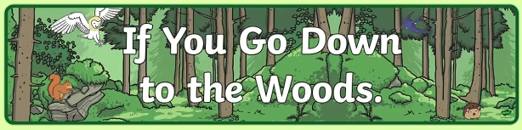

**Computing**

We will be writing our own algorithm to make a Bee-bot move.

**PE**

We will be improving our passing, attacking and defending skills while playing simple games.

**Art and Design**

We will be working on our observational drawing and painting skills, using water colours and oils pastels.

In Design Technology we will exploring different ways to join fabric together and creating our own bog baby.

**RE**

We will be exploring the big question ‘How do festivals bring a community together?’.

**English**

In English, we will be enjoying the story ‘The Bog Baby’ and ‘Tin Forest’. We will be writing a description of the Bog Baby and a recount of his visit to school.