April 2021
Dear Parents, Carers and Pupils,
Welcome back! I hope that you enjoyed the Easter festivities and had a restful spring break. Hopefully you are feeling suitably recharged, fresh and ready to embrace the challenges of the summer term.
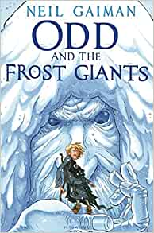
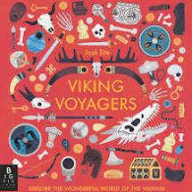
We will be learning about Vikings and Anglo-Saxons in History this half term which will link to our English where the children will be studying ‘Odd and the Frost Giants’ by Neil Gaimen and Chris Riddell. Our study of this book will focus on the theme of courage which is also the Christian value for this half term. In Guided Reading, we will be looking at ‘Viking Voyagers’ by Jack Tite. I am incredibly proud of the progress that the children are making with their English despite the interruptions that we have faced this year and hope that they will be inspired by the texts that we are studying and continue to develop their authorial flair.
I would also like to impress the importance of reading at home for supporting your child to develop their reading fluency and comprehension skills. Just 10 minutes a day can have a huge impact!
As ever, it is important for the children to continue to practice their times tables. Many children made a super effort during the Spring Term and this was reflected in the number of children that moved through phases in Tackling Tables, keep up the hard work! Remember, all the children have a log-in to the Tackling Tables App and are welcome to log-in and practice any time. If there are any problems with these do not hesitate to come in and let me know.
In Maths, we will begin by recapping place value before continuing to practise using the four operations (+, -, x, ÷) to solve calculations as well as looking at shape, space and measure and beginning to think more carefully about reasoning and problem solving which can be tricky as it requires the children to think in stages.
We will also be becoming experts in creating circuits as we learn about ‘Electricity’ in Science.
Forest Schools will be on Thursday afternoons for the first two weeks back and then the children will have 5 weeks of PE taking them up to half term. In the first 2 weeks PE will be on the Wednesday. Please remember to have PE kit, trainers and wellies in school at all necessary times. You are welcome to leave them in the cloakroom.
Spellings will be set on a Monday to tested on the following Monday and homework will be set through Sumdog and Tackling Tables.
I am delighted to announce that Mr Parr will be rejoining us on the 26th April to continue his teacher training. We are looking forward to welcoming him back.
If you have any questions or concerns, do not hesitate to make an appointment to come and see me.
With Kind Regards,
Mrs King and Mrs Garrard

