**RE**

Our big question is ‘How do Jewish people celebrate Passover?’. We will explore how and why Jewish people celebrate Passover.

**English**

In English, our work will be based on ‘The Adventures of Egg Box Dragon’. We will make our own dragons and then write instructions. We will also write an adventure story based on the book.

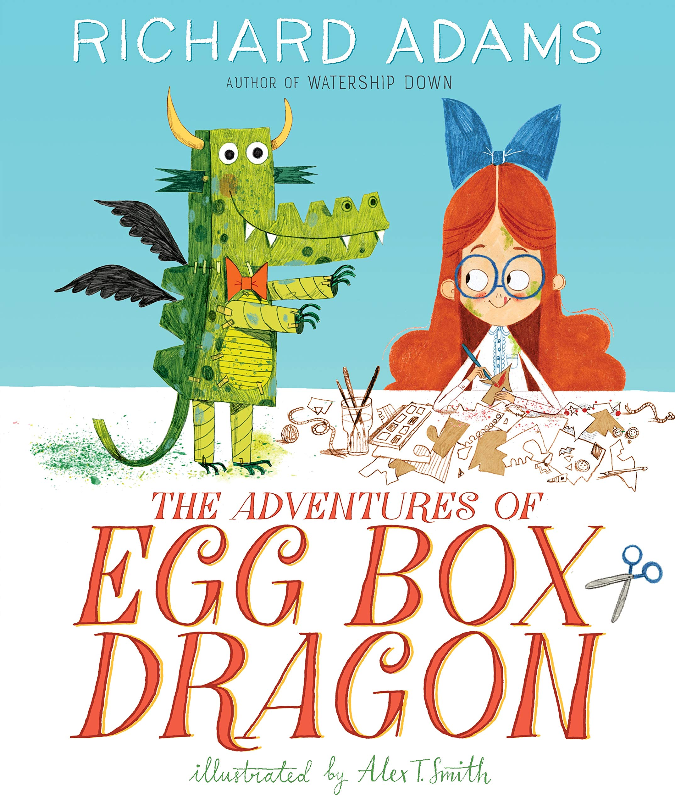

**Art and Design**

Our focus will be on creating portraits. We will use different media and experiment with different techniques and effects. We will look at the work of different portrait artists and choose our favourite style.

**History**

In our history lessons we will learn all about Queen Elizabeth and why we are celebrating a Platinum Jubilee this year. We will create a timeline of her life, find out about her coronation and look at how life has changed during her reign.

**PE**

We will be learning to play simple games to help practise our batting and fielding skills. Later in the term our attention will turn to athletics and preparations for sports day.

**Computing**

In computing, our focus will be on digital photography. We will learn the terms portrait and landscape and what makes a good photograph.

**Science**

In science our topic will be ‘Plants’. We will explore our school grounds to identify the plants that are growing here. We will also identify and name the different parts of the plant and learn the function of each part. We will plant seeds and learn what they need to grow and stay healthy.

**Year 1 and 2 Summer 2022**

**Our topic is**

**Queen Elizabeth II**

