June-July 2022
Dear Parents and Carers,
Welcome back! We hope you have all enjoyed the platinum Jubilee Celebrations over half term and look forward to you joining us at school on Friday for more!
Mrs Williamson will continue teaching Monday-Wednesday with Mrs Adams teaching Thursday-Friday. Mrs Garrard will continue supporting the class all week.
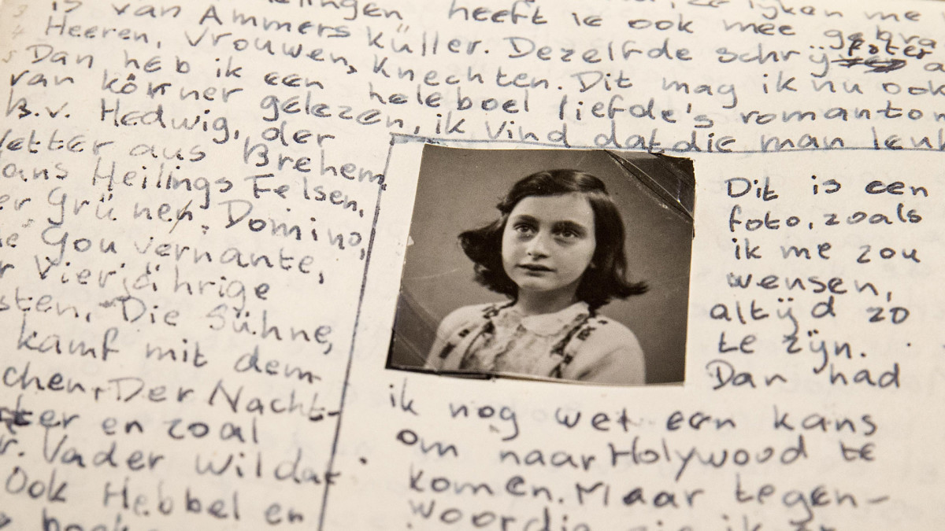
Here is a snapshot of our learning for the last part of the year:
Maths: We will be revising fractions and decimals, measurements and shape. We will be introducing basic algebra and looking at graphs and statistics.
English: Our text will be ‘The diary of Anne Frank’ and we will be writing our very own diary entries in role as well as writing character descriptions and letters. We will also be looking at ‘Tar Beach’ (set in 1939 Harlem) and writing our own explanation texts.
Other subjects: This half-term we will have a special week dedicated to learning about a decade of the Queen’s reign. We will be looking at the 1960s and hope to look at the World Cup in 1966, Andy Warhol art, the space race, and will be cooking food from the time. Our topic work in History will continue to be about WW2 but this term we also hope to explore the Local area and compare what it was like in wartime to the present day. We are very excited for this week’s visit to the North Norfolk Railway to re-enact a real evacuation and will be sharing our learning in our class assembly! Our Science work will be based around the states of matter and we will be completing investigations on gases, heating and cooling as well as looking at how the water cycle works. In Computing we will be revising all of the previous skills taught. Our Music sessions will involve lots of singing practice as we prepare for the Summer production with Mrs Reddey’s class. French will have a focus on ‘On the move’ and will include transport and directions, PSHE will cover citizenship in Britain additionally looking at Democracy, laws and our responsibilities. In Art and Design we will be looking at ‘drawing insects’ and will begin by looking at Austin’s Butterfly to demonstrate how perseverance helps us with our drawing. We will conclude our artwork by making an insect sculpture!
PE will be continued on a Thursday afternoon, interchanging with forest schools and the children will be learning about Athletics. As the weather gets warmer (we remain hopeful!), please make sure children have the correct kit and sun cream applied.
Reading: We would like to emphasise again the importance of reading at home. The children should have a reading book at all times and should be filling in their reading journals daily. They may wish to include the following in their reading journals: new vocabulary/phrases and what they mean, points of interest in what they are reading, book predictions/what will happen next etc. Reading journals will be checked and children will receive stickers if filled in properly. Thank-you for your continued support with this. In addition, there will be a dedicated reading comprehension session on the summer timetable to support children with these types of questions.
Spellings: Spelling sheets will come home every Friday after the new rule has been taught and a test has been taken. Please practise each week before the test.
Tackling Tables/Sumdog: As ever, it is important for the children to practice their times tables. We would really like to move the children on with their Tackling Tables this term and there will be a session dedicated to times tables. Remember, all the children have a log-in to the Tackling Tables App and are welcome to log-in and practise at any time. We will also be continuing our weekly times table test in class, Sumdog checks will be set weekly as well. If there are any problems with these do not hesitate to come in and let us know. Tackling Tables tests take place every Monday morning in our class and tables on a Friday morning Maths lessons’. Remember! In June, the Year 4 children will be taking the Multiplication Tables Check. This is completed online and more details will follow shortly. Please feel free to look at the government website: https://www.gov.uk/government/collections/multiplication-tables-check for additional information.
If you have any questions or concerns, do not hesitate to come and see us or drop us a line. Mrs Williamson can be contacted on rwilliamson@swn.dneat.org. Mrs Adams can be contacted on ruth.adams@swn.dneat.org and Mrs King is still available on cking@swn.dneat.org
Happy learning!
With kind regards,
Mrs Williamson, Mrs Adams, Mrs King and Mrs Garrard

